COMPUTER AIDED DESIGN WITH AUTOCAD

CAD LEVEL 1- Getting Started with AutoCAD

Topics covered in this Lesson:
- The X-Y Coordinate System |
- Angular Measurement |
- Entering Points in AutoCAD
- AutoCAD Basics |
- Terminology |
- The AutoCAD Screen
Welcome to the world of CAD - In this first tutorial you will be learning the very basics of CAD. This course is designed so that the commands and instructions should work on almost any version of AutoCAD, although this version is designed specifically for AutoCAD 2010 and will work great for 2012. By the end of this level you will have the skills to develop basic 2D drawings and print them out to scale. Let's start at the beginning, these things you need to know, or the rest of it won't make any sense at all. Make sure you have a very good understanding of this lesson before continuing. This lesson is longer than most (and not very exciting), but will cover important topics. Learn it, live it. Stick to it!

The X, Y coordinate system
Everything that you draw in AutoCAD is exact. It will be more accurate than you will ever need it to be. We're talking 14 decimal points accurate. All objects drawn on the screen are placed there based on a simple X,Y coordinate system. In AutoCAD this is known as the World Coordinate System (WCS). You must understand this to know how to put things where you want them. (3-D work has an added axis, the Z-axis, but this is not covered in this lesson.) Below is a diagram showing you how this system works (place your mouse on the diagram for more info)
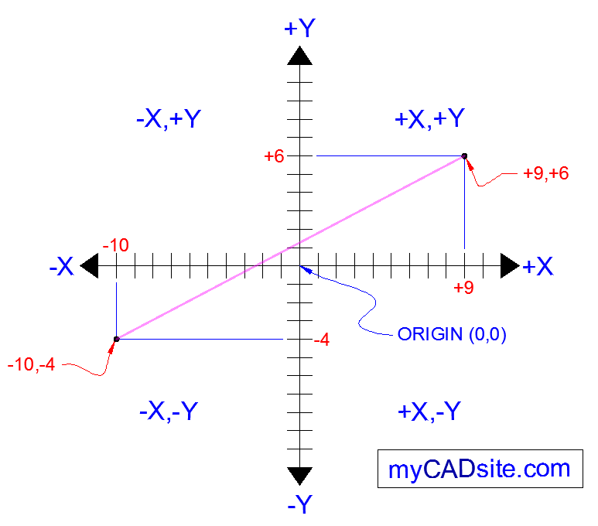

Here is how it works:
AutoCAD uses points to determine where an object is located. There is an origin where it begins counting from. This point is (0,0). Every object is located in relation to the origin. If you were to draw a line straight out to the right from the origin, this would be considered the positive X-axis. If you were to draw a line straight up, this would be the positive Y-axis. The picture above shows a point located at (9,6). This means that the point is 9 units over in the X-axis and 6 units up in the Y-axis. When you are working with points, X always comes first. The other point shown is (-10,-4). This means that the point is 10 units in the negative X-axis (left) and 4 units in the negative Y-axis (down).
A line has two points, a start point and an end point. AutoCAD works with the points to display the line on the screen. Move your cursor over the picture above and you will see line drawn from the absolute points of (-10,-4) to (9,6).
Most of the time you will not have an indication of where the origin is. You may need to draw a line from the endpoint of an existing line. To do this you use relative points. These work the same way, but you have to add the @ symbol (shift+2) to tell AutoCAD that this next point is relative from the last point entered. myCADsite.com
To review:
ABSOLUTE POINTS are exact points on the drawing space.
RELATIVE POINTS are relative to an OBJECT on the drawing space.
It's a simple system, but mastering it is the key to working with AutoCAD and is explained in more detail further below. In order to work effectively with AutoCAD, you have to work with this system. Until you are comfortable and familiar with it, learning AutoCAD will be more of a chore. My experience in teaching is that the better a student is with coordinates, the faster they will learn.

Angular Measurement
AutoCAD measures angles in a particular way also. Look at the diagram below and then place your mouse on it to see how this is done.
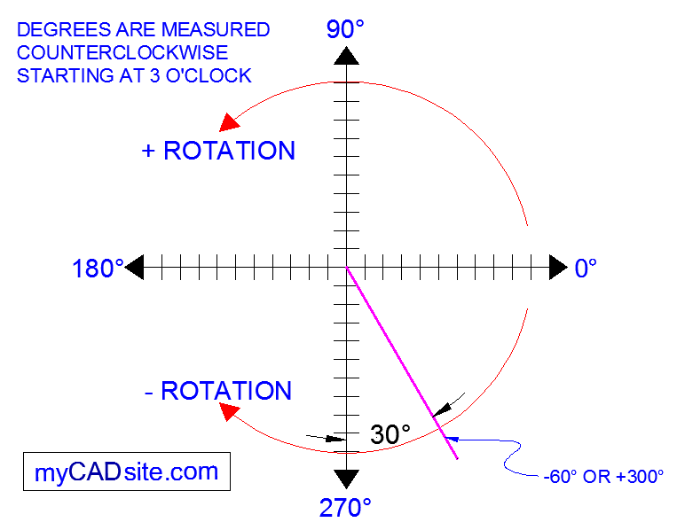

When drawing lines at an angle, you have to begin measuring the angle from 0 degrees, which is at the 3 o'clock position. If you drew a line at 90 degrees, it would go straight up. The example above (when you move your mouse over it) shows a line drawn at +300 degrees (270+30), or -60 degrees.
You might not always have an obvious reference point for 0 degrees. Look at the example below and place your mouse on the image to find out the angle in question.
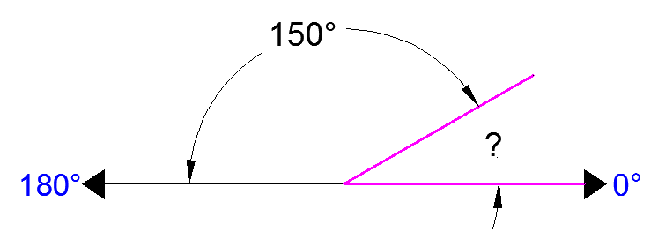
In this example, you are given information about the lines, but not the angle AutoCAD needs to draw the line from the start point. What you are given though, is (a) the knowledge that 0° is at the 3 o'clock position (b) the knowledge that 180° is at the 9 o'clock position and (c) the angle between 180° and the line you want to draw is 150°. With this information, you can figure out what angle you need. Here is a fool-proof way of getting the angle you need:
1.) Start at the 0° position and measure counter-clockwise (+) to 180°.
2.) From 180°, measure clockwise 150° (-)
3.) Consider that you just went +180-150 and use that as an equation: +180-150=30
4.) Now you can draw your line using polar coordinates (discussed below)

Entering Points in AutoCAD
You can enter points directly on the command line using three different systems. The one you use will depend on which is more applicable for the situation. The first assignment will get you used to this. The three systems are as follows:
ABSOLUTE CO-ORDINATES - Using this method, you enter the points as they relate to the origin of the WCS. To enter a point just enter in the exact point as X,Y.
RELATIVE CO-ORDINATES - This allows you to enter points in relation to the first point you have entered. After you've entered one point, the next would be entered as @X,Y. This means that AutoCAD will draw a line from the first point to another point X units over and Y units up relative to the previous point.
POLAR CO-ORDINATES - You would use this system if you know that you want to draw a line a certain distance at a particular angle. You would enter this as @D<A. In this case, D is the distance and A is the angle. Example: @10<90 will draw a line 10 units straight up from the first point.
The three ways of entering coordinates shown above are the ONLY way AutoCAD accepts keyboard input. First decide which style you need to use, and then enter as shown. Remember that X is always before Y (alphabetical). Don't forget the '@' symbol when you are entering relative points. Any typing error or omission will give you results you don't want. If you make a mistake and need to see what you typed, press F2 to bring up the text screen and check your typing. (press F2 to get back to your drawing.)

More Autocad Basics
Subjects covered in this section:
The AutoCAD screen - Workspaces - Starting Commands - Terminology

The AutoCAD Screen

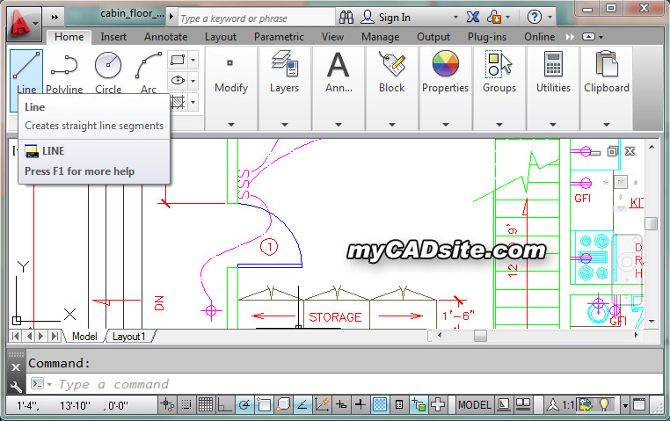

Move your cursor around the image above to find the names of various areas of the screen.
- Application Button - This button displays commands for printing, saving, drawing utilities and other non-drawing tools.
- Quick Access Toolbar - This is for quick access to common commands like New, Open, Save, Plot
- Filename - The name of the current file you are working on.
- Search Bar - Search for text in your drawing or search the help files.
- Ribbon - The Ribbon has most of the commands/tools that you will use while you are working.
- Tabs - A series of Tabs make up the Ribbon (Home, Insert, Manage, etc) and organize the Tools into common groups.
- Panels - Contain a group of tools
- Tools - These are the icons that start the commands you use to draw, modify, etc.
- Tool Tip - If you hover your mouse over a tool, a tool tip will appear to give you more information. Hold it longer for more info.
- Drawing Space - These is where you draw your designs.
- Command line - When you type a command, you will see it here. AutoCAD uses this space to 'prompt' you for information. It will give you a lot of information and tell you where you are in the command. Watch this line while learning.
- Status bar - This allows to see and change different modes of drawing such as Ortho, Osnaps, Grid, Otrack, etc. You can right click this area to toggle between icons and text for this area.
- Workspaces
- With the introduction of AutoCAD 2009, a new screen layout was added. The program now allows you to work in different workspaces depending upon what you are working on. For example, the screen will look different if you are working on 2D than it will with 3D work. There is also an option for AutoCAD Classic (which is how the screen looked from Versions 2000-2008). This set of tutorials will deal with the new new workspace. Since you are a new user, you may as well learn the new interface. If you want to use the Classic interface, you can use the tutorials for AutoCAD 2008.
- For the first 2 levels of tutorials, you will want to be in the 2D Drafting & Annotation workspace. Set this by clicking in the bottom right of the AutoCAD screen on the 'gear' icon as shown in the image below. In AutoCAD 2012, this is at the top of the screen.

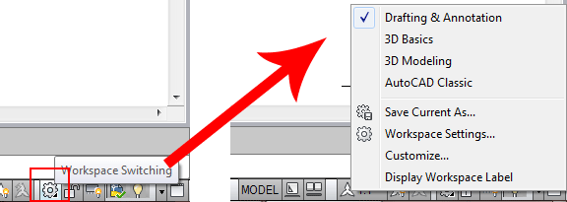

Icons, Keystrokes and Menus
There are many ways to do things in most Windows programs. AutoCAD is no exception. Everyone will develop a way that works best for him or her. In this course, we will primarily be working with the keystroke commands. The reason for this is because they will work in most AutoCAD versions (including DOS versions), and in some other CAD programs. The icons work well, but as you will see, icons can be placed anywhere on the screen and can be difficult to find quickly. You may be working on another employee's computer that is set up differently than what you're used to. The pull-down menus will access almost all commands, but are a slower way of doing things. Icons in AutoCAD 2010 are found on the ribbon, divided into panels - just click on the appropriate tab to open the panel you need..
Example: If you want to draw a line, you can do it a few ways:
- At the command line type: LINE (or) L and press the ENTER key.
- Select the line icon from the DRAW Panel.
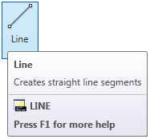
Another way is to Right-Click on the drawing space and choose "Recent Input" from the menu. This will give a list of the most recent commands that you have used.
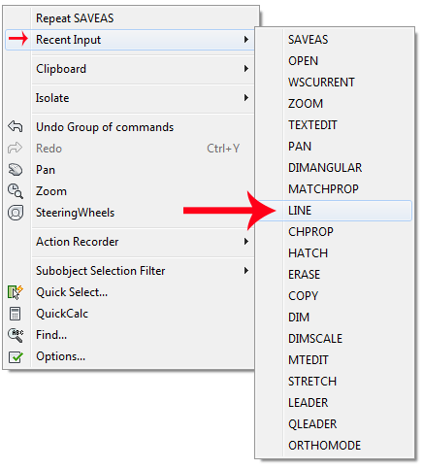
All three approaches will do the same thing: prepare AutoCAD to draw a line where you tell it.
AutoCAD is a popular program because it can be customized to suit an individual's needs. The toolbars are a good example of this. You can have the toolbars you use most often on the screen all the time. You can easily make them go away so that you have more drawing space. You can also customize them so you have the most common commands on one toolbar. For example, the dimensioning toolbar is one that you will not want taking up space on your screen while drawing, but is very handy when you're dimensioning your drawing.
To remove the ribbon and have the most drawing space available, click on the "Clean Screen" icon in the bottom right corner of the screen (or press CTRL+O [letter O]). To go back to the standard display, click again on the same icon.

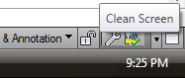

Basic AutoCAD Terminology
Here are some basic terms that you will want to review before using AutoCAD. Some terms have links to give you more information (but it is not necessary to memorize them all now).
Absolute coordinates | A way of inputting points based on AutoCAD's origin.
Acad.dwt | This is the default template that automatically loads whenever you start a drawing session. It can be customized to suit your needs.
Associated Dimensioning | Dimensions that are associated with specific points will update as that point is moved.
Backup file | AutoCAD can be set to automatically backup your drawing and save it. This is a safeguard in case your file gets corrupted. It is saved with a .BAK extension
Block | A pre-drawn image you can insert in your drawing to save time and make your file size smaller.
Clean Screen | A display setting that gives you maximum drawing space.
Crosshairs | This is your cursor when it is in the drawing space.
Cursor | Your cursor will change depending on what function it is performing in the program.
Database | An AutoCAD drawing file is actually one large database containing all the information needed to reproduce the objects when the file is opened. Info for layers and linetypes, etc are stored in this manner.
Dialog box | AutoCAD uses a large number of dialog boxes to get information from you. You must know how to input the information that it asks for.
Drawing template file | This is a file that contains preset values for frequently used settings. AKA a prototype drawing. The file extension is DWT.
Extents | The outer boundaries of the objects you have drawn.
Grid | This is pattern of dots displayed on the screen to guide you. It can be toggled on and off by pressing the F7 key.
Grips | Small 'handles' on objects that allow for quick editing.
Layer | All objects are drawn on a layer. You can group objects (such as electrical) on a single layer and organize your drawing.
Layout Tabs | A space used for plotting your drawings (formerly called Paper Space).
Limits (Grid) | A setting to impose an 'artificial' boundary on your drawing that sets the area of the grid, and when turned on, limits you to drawing in the grid area.
Linetype | All objects are drawn with a particular linetype. Examples would be solid, center, dashed, etc.
Model space | The drawing space where you 'model' the objects.
Modify | A generic term used for changing your objects
Object | Any item that is in the AutoCAD database. Also known as an entity.
Origin | The (0,0) point of your current coordinate system.
Ortho mode | This is a drawing mode that allows you to draw only perpendicular lines. It is toggled on and off by pressing the F8 key.
Orthographic Projection | A standard drawing method that shows 2 or more views of the same part.
Osnap - Object Snap | This is a method of 'snapping' to certain, precise points on an object.
Pan | To move around the drawing by dragging the drawing area around your screen.
Panel | A grouping of commands on the ribbon
Path | The specific folder where AutoCAD looks for, or saves files.
Pick | To select an object by 'left-clicking' on it.
Plot | Also known as print. To make a hard copy of your drawing.
Polar coordinates | A way of inputting points based on distance and angle.
Property | Any specific characteristic of an object such as layer, scale, linetype, start point, etc.
Ribbon | The Ribbon runs across the top of the drawing space and contains panels - each panel has a group of associated tools. Switch to different panels by clicking on the tabs at the top of the ribbon.
Relative coordinates | A way of inputting points based on a starting point.
Section View | A drawing that represents a cross section of a part or assembly.
Selection set | The current group of objects selected for modifying.
Snap | This is a drawing mode that allows you to snap your cursor to precise points laid out in a grid pattern. Toggle with the F9 key.
Styles | Formatting that defines the look of text, dimensions, etc.
Units | The basic drawing unit set for your drawing. For example, you can use inches or millimeters depending on your needs. You can also set the precision you want displayed, such nearest 1/4", 1/2" 1/64", etc.
User coordinate system (UCS) | Modifications made to the World Coordinate System (WCS) result in a User Coordinate System (UCS)
View | A particular area of your drawing.
Viewport | A separate 'window' on your drawing. You may have more than one viewport visible to see different areas of your drawing at the same time.
Wizard | An easy step-by-step instruction set to help you set-up certain aspects of your drawing.
World Coordinate System (WCS) | This is the common X-Y coordinate system that is the default. If it is modified, it becomes a User Coordinate System (UCS)
Zoom | To view either a smaller section of your drawing (zoom in) or a larger section (zoom out)

LESSON 1-2 ASSIGNMENT 1 INTRODUCTION TO DRAWING & MODIFYING

Topics covered in this Lesson:
- Line
- Circle
- Erase
- Print
- Undo
AutoCAD allows you to have access to a large number of commands. A general rule is that you will use 20% of the commands 80% of the time. I will start by introducing you to the most common drawing commands. When you combine these with the basic modify commands, you will be able to make elaborate drawings quite quickly. In other words, most of the commands you will use while using AutoCAD are taught in Level 1.
The important thing to remember is that AutoCAD will expect you give it information in a very particular order. The most frustrating thing when you begin using this program is that you will try to do something, but AutoCAD will 'not work'. In most cases, it means that you are trying to input information at the wrong time. This is why it is very important to be in the habit of looking at the command line.
The command line tells you what information AutoCAD requires to continue.
Your first drawing assignment will be to use the drawing commands in conjunction with the co-ordinate system defined in Lesson 1-1. This is a basic assignment, but it is very important to understand how to give the program accurate information. You will use the following commands:
Command | Keystroke | Icon | Location | Result
Line | Line / L | 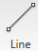 | Home > LIne | Draw a straight line segment from one point to the next
Circle | Circle / C |  | Home> Circle > Center, Radius | Draws a circle based on a center point and radius.
Erase | Erase / E |  | Modify > Erase | Erases an object.
Arc | Arc / E |  | Draw > Arc > Center, Start, End | Draws an arc based on a center point and 2 endpoints
Print | Print / Plot CTRL+P |  | Quick Access Toolbar > Print | Enables the Print/Plot Configuration Dialog Box
Undo | U / CTRL+Z |  | Quick Access Toolbar> Undo | Undoes the last command.

Assignment #1 - Drawing lines to exact points
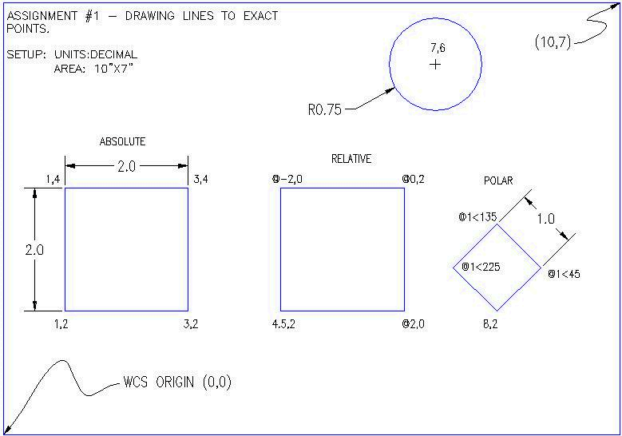

You will not have to worry about the title block or text, or dimensioning.
Make sure you are comfortable with the co-ordinate system as explained in Lesson 1-1. When you are finished this assignment, check the printed drawing with a scale ruler. All lines should measure up exactly if all went well.
Steps:
Start AutoCAD and a new drawing by pressing the Application Button (top left corner) and pressing the new button to reveal the flyout. Once you see the flyout, click on Drawing.
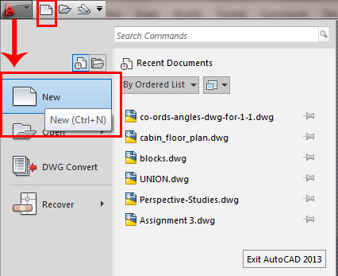
There are 3 ways to start a new drawing. The fastest is to press CTRL+N, but you can use the two icons shown in the image above. Any way you do this, you will see a dialog box open that asks you to select a template drawing to use (as shown below):
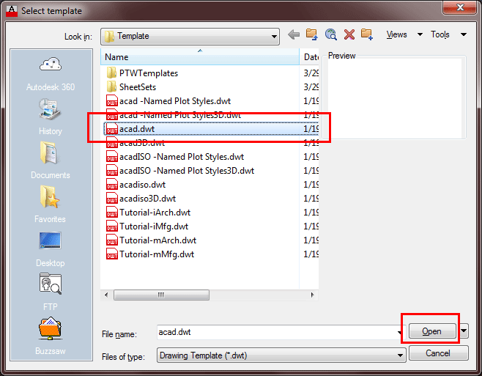
If AutoCAD doesn't locate your templates automatically, they can be hard to find. Have a look in your:
C:\Users\[PROFILE]\AppData\Local\Autodesk\AutoCAD 2013 - English\R19.0\enu\Template folder. You will find it there. Of course, you can also copy your templates to a folder that is easier to locate.
Select the "acad.dwt" template file and press the Open button to continue to the drawing screen.
Once there, type in Z <ENTER> E <ENTER> this will zoom into to the extents of the drawing area and make it easier to see what you are drawing (NOTE: nothing will appear to happen). Also if you find that the grid distracts you, you can press F7 to toggle it on or off.
For all lessons on this level, make sure that you do not have Dynamic Input turned on. You can check this on the status bar. Make sure the DYN button isn't depressed. Your status bar buttons (bottom of the screen) should like the image above with the Dynamic Input button grey.
Start the LINE command (as explained in the table above) and draw a line from 1,2 to 3,2 to 3,4 to 1,4 Press enter after each point. (*Remember to watch the command line as you do this.) For the last line, you can either type in 1,2 or C to close the line back to the first point you entered. You have just drawn a 2" square using absolute co-ordinates. Your command history (F2 key) should look like this:
Command: L LINE
Specify first point: 1,2
Specify next point or [Undo]: 3,2
Specify next point or [Undo]: 3,4
Specify next point or [Close/Undo]: 1,4
Specify next point or [Close/Undo]: 1,2
Specify next point or [Close/Undo]: <ENTER>
If you make a mistake, you can use the undo icon, press U or press CTRL+Z.
You can also use the ERASE command to get rid of lines you don't want.
Next draw a similar box using relative co-ordinates. Start the LINE command and begin at point 4.5,2. From there draw a line two units to the right by typing @2,0 (this means 2 units in the X direction, 0 units in the Y direction based on the last point you entered). Next type @0,2 then @-2,0 then @0,-2 to finish the box. (Remember to press enter after each point.)
Now erase the last box you just drew. Start the ERASE command and then select the lines you want to erase. Then press <enter>. Now redraw the box for more practice!
Draw a third box using polar co-ordinate input. Start the LINE command and begin at point 8,2 then enter. Type @1<45 to draw the first line. Next enter @1<135 then @1<225 then @1<315 (or C to close). What you have just done is drawn a line 1 unit long at 45º, then another at 135º and so on. Do the angles you entered make sense to you? If not, review it.
Start the CIRCLE command and add a circle that has a center point at 7,6 with a radius of .75 (Watch the command line for instructions).
The last thing to draw is the arc (curved line) that you see in the bottom left square. Start the ARC command and select the Center option by pressing the "C" key.
Now you can enter the center point which will be 1,2. Then you'll be prompted for the start point, enter 3.2 and finally the end point 1,4.
Command: A <enter> ARC
Specify start point of arc or [Center]: C
Specify center point of arc: 1,2
Specify start point of arc: 3,2
Specify end point of arc or [Angle/chord Length]: 1,4
There are many different ways to draw an arc. Try another method in the other square. Also, you'll learn later that you can draw a circle and then trim it to leave an arc.
To finish the drawing, try putting a 10"x7" border around the page starting at 0,0 using the any of the methods shown above (relative, absolute or polar).
When you have done the assignment, the next step is to print (or plot) it out. To do this, bring up the plot dialog box using any method explained above (plot <enter> will work). Set it up to print as shown below. Follow these steps for a successful plot (see diagram below):
- Select your printer - laser or inkjet will work fine.
- Select the paper size - "Letter" ( 8-1/2" x 11") is needed in this case.
- For the "Plot Area", select "Extents" - that will plot everything you drew.
- Select the checkbox to "Center the Plot" on your sheet of paper (looks better).
- If "Fit to Paper" is selected by default, uncheck it and select a scale of 1 inch to 1 paper unit (1:1). This will make your printout 'life-sized'.
- Now Preview your drawing. I strongly recommend that you preview EVERY drawing you will ever draw in AutoCAD - a lot can go wrong, so you don't want to waste paper (especially when you're using expensive 3'x4' sheets!).If your preview looks good, Cancel out of the preview by pressing ESC.
- If you're sure that everything's ok (this is where good habits begin), press the OK button.
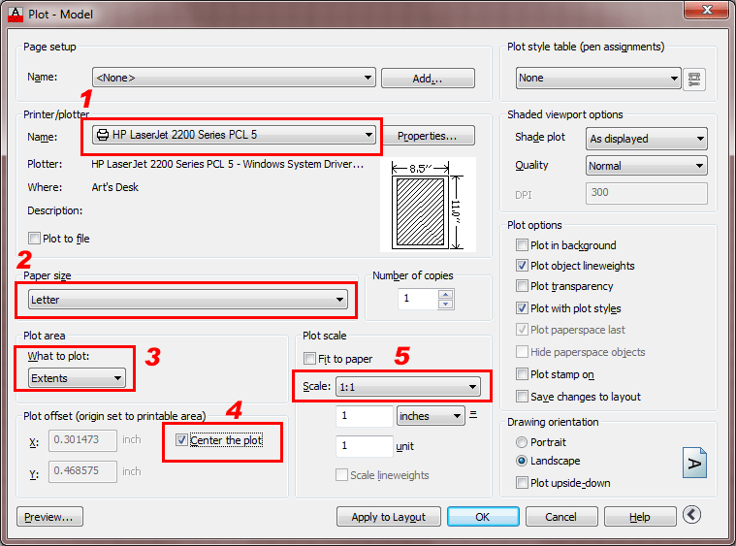

Note: You may have to change the paper size in your printer (Use the Windows printer settings to do this.) You may also have to change the rotation or origin of the plot. Check the Landscape radio button in the Drawing Orientation section.
If everything worked out, you should be able to measure your drawing and have it exactly the way you drew it (a couple of 2" squares, an angled 1" square and a 1-1/2" circle).
Save your drawing as you would any other Windows file. CTRL+S will bring up the Save or Save as dialog box.
If you want to check your input, click HERE to see the commands needed to complete this assignment.
The following is a list of all the commands required to complete Assignment 1. If your results are different than the sample drawing file, check your input against these. Press the F2 key to see your input. (Press F2 to close the text screen).
Command: line <enter>
Specify first point: 1,2 <enter>
Specify next point or [Undo]: 3,2 <enter>
Specify next point or [Undo]: 3,4 <enter>
Specify next point or [Close/Undo]: 1,4 <enter>
Specify next point or [Close/Undo]: c <enter>
(Completes the first box)
Command: l <enter>
LINE Specify first point: 4.5,2 <enter>
Specify next point or [Undo]: @2,0 <enter>
Specify next point or [Undo]: @0,2 <enter>
Specify next point or [Close/Undo]: @-2,0 <enter>
Specify next point or [Close/Undo]: @0,-2 <enter>
Specify next point or [Close/Undo]: <enter>
Completes the second box
Command: l
LINE Specify first point: 8,2
Specify next point or [Undo]: @1<45
Specify next point or [Undo]: @1<135
Specify next point or [Close/Undo]: @1<225
Specify next point or [Close/Undo]: @1<315
Specify next point or [Close/Undo]:
Completes the 3rd, angled box
Command: c
CIRCLE Specify center point for circle or [3P/2P/Ttr (tan tan radius)]: 7,6
Specify radius of circle or [Diameter]: .75
Completes the circle
Command: l
LINE Specify first point: 0,0
Specify next point or [Undo]: @10,0
Specify next point or [Undo]: @0,7
Specify next point or [Close/Undo]: @-10,0
Specify next point or [Close/Undo]: c
Completes the border
Command: save
Command: plot

This assignment has given you a basic introduction to drawing using a variety of methods. Once you have completed the assignment, practice these methods, as you will be using them often.
Your boxes should match the drawing example. They will be the same size and on the same place in the drawing. If you have a ruler, you will see that your lines are life-size (1:1). From these basic concepts, you can now draw lines anywhere if you know where they should go. The next lessons will add to these commands. As you get used to the AutoCAD interface, you will find it easier and easier to learn the new commands. But for now, mastering the co-ordinate systems, inputting commands and reading the command line should be your priority.

LESSON 1-3 ASSIGNMENT 2 MORE MODIFYING COMMANDS - OSNAPS
- Topics covered in this Lesson:
- Rectangle
- Extend
- Offset
- Trim
- Introduction to Object Snaps
The previous lesson dealt with drawing commands. This lesson will introduce some common modifying commands. In AutoCAD, you may actually use modifying commands more often than drawing commands. Now that you know the basics, here's some more commands to add to your collection. Three commands, Trim, Extend and Offset are used often in 2D AutoCAD work.

Command | Keystroke | Icon | Location | Result
Rectangle | RECTANGLE / REC |  | H ome > Draw > Rectangle | Draws a rectangle after you enter one corner and then the second.
Trim | TRIM / TR |  | Home > Modify > Trim
 | Trims objects to a selected cutting edge.
Extend | EXTEND / EX |  | Home > Modify > Extend | Extends objects to a selected boundary edge.
Offset | OFFSET / O |  | Home > Modify > Offset | Offsets an object (parallel) by a set distance.
Object Snaps OSNAP / OS / F3 CLICK
Tools > Object
Snap Settings Brings up the OSNAP dialog box.

Assignment #2 - Modifying Commands
The purpose of this assignment is to use the commands learned in the previous lesson and learn some new ones.
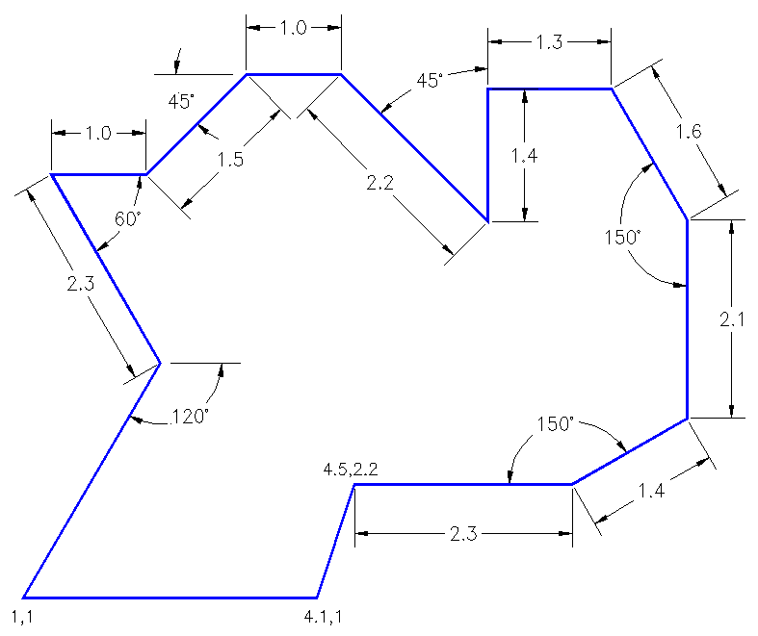
- Open AutoCAD and set up the drawing as you have for the previous assignments using a template.
- Complete the assignment by drawing it accurately using the dimensions provided.
- If you make an error along the way, remember that you can use your ENDPOINT Osnap to begin where you left off.
- Save your drawing.
- Print your drawing using the guidelines given in the previous assignments.

Once again, do not worry about title blocks, text or dimensions, draw only the geometry (in green).
Start AutoCAD and begin the the drawing by opening up the template file like you did in Lesson 1-2.
Draw a LINE from 1,2 to 3,2 to 3,4 to 1,4 (*Remember to watch the command line as you do this.) For the last line's endpoint , you can either type in 1,2 or C to close the line back to the first point you entered. These are absolute coordinates. Make sure you understand what the points your just entered represent.
Draw the next square using the RECTANGLE command. A rectangle is created by specifying 2 points to represent the opposite corners. Enter the first point as 4.5,2 and then make the opposite corner 2 inches over and 2 inches up @2,2 using relative coordinates. This is much faster and also makes the square one object and not 4 separate lines.
ERASE the rectangle. You will see that all of it is gone with one pick. Redraw it and continue.
For the 3rd square, draw a 1.5 x 1.5 unit square using any of the methods you know. The bottom left corner must be at 8,2.
Draw a line from 2,5 to 2,6.5 Draw another line from 1,6 to 3,6 You should now have two perpendicular lines. What you want to do is trim off the top of the vertical line and create a T.
Start the TRIM command. It will first ask for a cutting edge. Select the horizontal line and press <ENTER>. It will now ask for the object to be trimmed. Select the vertical line anywhere above the horizontal (cutting) line and press <ENTER> to finish the command.
This is what you saw on the command line:
Command: TR <enter> TRIM
Current settings: Projection=UCS, Edge=None
Select cutting edges ...
Select objects: <Select the Horizontal line> 1 found
Select objects: <enter>
Select object to trim or shift-select to extend or [Fence/Crossing/Project/Edge/eRase/Undo]: <Select the vertical line>
Select object to trim or shift-select to extend or [Project/Edge/Undo]: <enter>
Once again, it is important to keep your eye on the command line as it will guide you through most commands.
Draw a LINE from 4,6.5 to 6,6.5 Draw another line from 5,5 to 5,6 What you want to do now is extend the vertical line up to the meet horizontal line. Start the EXTEND command. AutoCAD asks for a boundary edge; select the horizontal line press <ENTER>. It then asks for an object to extend; select somewhere in the top half of the vertical line. Press <ENTER> to end the command. Your command line history should match what is shown below.
Command: EX <enter> EXTEND
Current settings: Projection=UCS, Edge=None
Select boundary edges ...
Select objects: <Select the horizontal line> 1 found
Select objects: <enter>
Select object to extend or shift-select to trim or [Fence/Crossing/Project/Edge/Undo]: <Select the top half of the vertical line>
Select object to extend or shift-select to trim or [Project/Edge/Undo]: <enter>
Draw a CIRCLE with a center point of 7.5,5.5 with a radius of .5 Now you will use to offset command to make another circle 1/4" larger. Start the OFFSET command (watch the command line) and enter .125 as the offset distance (1/2 of 1/4"). Now select the circle and pick anywhere outside the circle. Press <ENTER> to end the command.

Object Snaps
Suppose you want to draw a line from the center of the circle to the middle of the vertical line you extended earlier. AutoCAD has a feature that makes this very easy. These are the Object Snaps (or Osnaps "Oh-Snaps"). Type OS <ENTER> . You will see this dialog box appear.
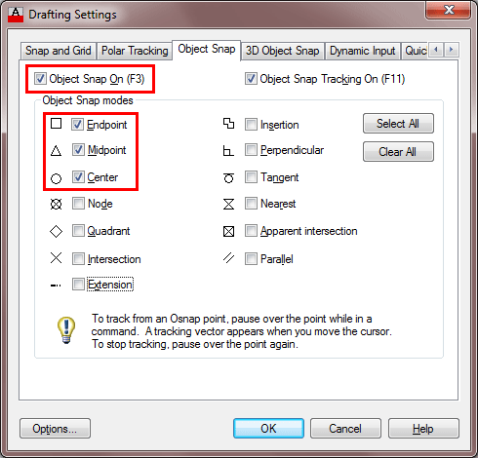

ICON | SETTING |  | ICON | SETTING
 | Endpoint |  |  | Insertion Point
 | Midpoint |  |  | Perpendicular
 | Center |  |  | Tangent
 | Node |  | > | Nearest
 | Quadrant |  |  | Apparent Intersection
 | Intersection |  |  | Parallel
 | Extension |  | M2P | Midpoint between 2 points
You may select whichever points you want to 'snap' on an object. Here is a list of your options. Followed by the command entry to invoke the needed Osnap.
Endpoint - snaps to either the beginning or the end of an object such as a line - END
Midpoint - snaps to the exact middle of a line or an arc - MID
Center - snaps to the center-point of a circle or arc - CEN
Node - snaps to 'nodes' (not covered in this course) - NOD
Quadrant - snaps to any of the four quadrants of a circle - QUA
Intersection - snaps to the point where two object cross - INT
Extension - Snaps to the phantom extension of an arc or line - EXT
Insertion - snaps to the insertion point of an object (such as a block or text) - INS
Perpendicular - will snap so that the result is perpendicular to line selected - PER
Tangent - snaps to create a line tangent to a circle or arc - TAN
Nearest - will find the closest point an object and snap to that point - NEA
Parallel -Snaps parallel to a specified line - PAR
M2P - This isn't technically an 'Object Snap' as you are not snapping to specific point on an object, but it allows you to select 2 points and it will calculate the midpoint between those 2 points. This is a very handy option to have.

Note: Beside each checkbox is a symbol. That symbol will show up on the screen when you have found a valid snap point. (An endpoint will show a small square). If you select the "Options" button, you can change the aperture size and the color of the Osnaps. Depending upon the background you are drawing on, this may be needed. Osnaps are explained in more depth in tutorial 4-2, but this will be enough for you now.
- Check off the boxes as shown in the dialog box above (Object Snaps On, Endpoint, Midpoint, Center) and press OK.
- Begin the LINE command. Move your cursor around the screen and you'll see that as you get close to an object, it will 'snap' to one of the points that you had checked off in the dialog box. Place your cursor on the circle (not the middle of the circle) until you see a small purple circle appear at its center. Left-click to make this the start point of the line. Move the cursor towards the middle of the vertical line until you see a small triangle appear. (Remember this is the symbol for 'midpoint'). When you see it left-click to accept this as your endpoint. Press <ENTER> to end the line command.
- Save your drawing.
- Print your drawing with the same settings as in Assignment #1. Don't forget to use the preview.

LESSON 1-4 :ASSIGNMENT 3 - ACCURATE INPUT
Topics covered in this Lesson:

Review and practice of accurate input
Now it's time to see if you were paying attention in the first lesson. In this lesson you will complete the drawing that will test your knowledge of drawing accurately using different types of precision input. Clients expect 100% accurate drawings from YOU. It is up to the YOU to ensure that YOU have the ability to draw quickly and accurately. There is no room for error when drafting, as you need to read accurately, transfer the numbers to AutoCAD accurately, and draw accurately. It is the job of this exercise to help you learn to draw accurately - speed will come only through practice.
Print the file out and try to reproduce it. Start at the bottom left corner (1,1). Use the drawing tools you have learned in the previous lessons. You will have to use a combination of absolute, relative, and polar coordinate input.
- Open AutoCAD and set up the drawing as you have for the previous assignments using a template.
- Complete the assignment by drawing it accurately using the dimensions provided.
- If you make an error along the way, remember that you can use your ENDPOINT Osnap to begin where you left off.
- Save your drawing.
- Print your drawing using the guidelines given in the previous assignments.
The following is a list of all the commands required to complete Assignment 3. If your results are different than the sample drawing file, check your input against these. Press the F2 key to see your input. (Press F2 to close the text screen).
NOTE: If you are using AutoCAD R14 (or earlier), your command line may look different, but the input will still be the same.
Remember to press ENTER after entering each co-ordinate point.
Command: l LINE
From point: 1,1
Specify next point or [Undo]: 4.1,1
Specify next point or [Undo]: 4.5,2.2
Specify next point or [Close/Undo]: @2.3,0
Specify next point or [Close/Undo]: @1.4<30
Specify next point or [Close/Undo]: @0,2.1
Specify next point or [Close/Undo]: @1.6<120
Specify next point or [Close/Undo]: @-1.3,0
Specify next point or [Close/Undo]: @0,-1.4
Specify next point or [Close/Undo]: @2.2<135
Specify next point or [Close/Undo]: @-1,0
Specify next point or [Close/Undo]: @1.5<225
Specify next point or [Close/Undo]: @-1,0
Specify next point or [Close/Undo]: @2.3<-60
Specify next point or [Close/Undo]: 1,1

LESSON 1-5 SELECTION SETS
Topics covered in this Lesson:
- Creating Selection Sets
- Changing your options
By now you have probably seen a colored rectangle appear on your screen when you left-click and the move the crosshairs around. You'll learn all about these in this lesson. AutoCAD uses what's called a selection set to allow you to group objects together and then modify them. For example, if you want to erase several lines, you could press E <ENTER>, pick on the line, press <ENTER> again and repeat until you're done. Another way would be to press E <ENTER>, and then pick the lines one by one until they are all selected, and press <ENTER>. By selecting a group of objects, you have created a selection set. Whenever you want to modify an object, and are asked by AutoCAD to "select objects" you can create a selection set and then apply the command.
REMEMBER TO PRESS ENTER WHEN YOU ARE FINISHED SELECTING THE OBJECTS
There are also a few other ways to create a selection set. The most common way is to use a window.
There are two very different types of windows you can use.
One is a 'crossing selection and the other is a 'window selection' (or 'box'). If you create the selection from right to left, you make a crossing window. This means that any object that crosses the border or is surrounded by the window is added to the selection set. This is shown as a green rectangle with a dotted outline on the screen. If you create the window from left to right, you create a box. Using this method you'll add only the items that are completely within the box. This is shown as a blue box on the screen. The difference is very important.

To summarize:
DIRECTION | CALLED | DISPLAY | EFFECT
RIGHT TO LEFT | CROSSING SELECTION | GREEN | SECLECTS ANY OBJECT THAT EITHER CROSSES THE BOUNDARY OR IS INSIDE IT
(with a dotted outline)
LEFT TO RIGHT | WINDOW SELCTION | BLUE | SELECTS ON OBJECTS THAT ARE COMPLETELY WITHIN THE BOX
There are other ways to select objects and here a few of the more common ways. These can also be used in combination.
REMOVE - by typing R when asked to select objects, AutoCAD will select change to allow you to Remove objects from the selection set. You can also remove individual objects by pressing the Shift Key when selecting (known as a 'shift-select')
LAST - by typing L when asked to select objects, AutoCAD will select the last object that you created. This is handy if you create something and want to move or modify it right away.
PREVIOUS - by typing P when asked to select objects, AutoCAD will select the previous selection set. This is used if you select a few objects, modify them and then want to modify them again.
FENCE - by typing F when asked to select objects, AutoCAD allows you to draw a series of lines (called a fence) to select objects. This is convenient if you want to select a group of lines to be trimmed to a single cutting edge.
CROSSING POLYGON - typing CP when you are selecting objects give the ability to create a crossing polygon for object selection. This is similar to a crossing box (drawn like a Fence), but you can pick points on the screen to create a polygon. By default, this is a crossing polygon, therefore any objects that cross the polygon will be added to the selection set.
CROSSING WINDOW - typing WP (window polygon) when you are selecting objects give the ability to create a crossing window for object selection. This is similar to a crossing box, but you can pick points on the screen to create a polygon. This is a crossing window, therefore any objects that are completely within the polygon will be added to the selection set. Newer versions of AutoCAD allow you to use your cursor to create a crossing window without typing in the 'CW'.
CYCLING - When are ready to select objects, hold down the Shift key on your keyboard and then press the Space Bar when your mouse is on top of overlapping objects. Repeatedly press the Space Bar until the one object you want to modify is highlighted. Then pick with the mouse. This is a good approach if you have many objects in a small area.
To deselect everything you have selected, you just press the escape key on your keyboard or right-click and choose "Deselect All" from the menu.
TIP: Zoom in when selecting in tight spaces. Make sure you are 100% sure you are selecting the correct object. Imagine the difference of offsetting an interior wall instead of the exterior wall - the resulting object would be off by over 6 inches! Get used to zooming in, then zooming out quickly (the mouse wheel is great for this).
Changing your selection options
Many people are happy with the default AutoCAD settings. Sometimes you might want to change your settings for things like your grip or pickbox size. This is totally personal and it's your call. I'll show how to change these, but remember where the settings are in case you want to change them back.
Type in OP for Options and look for the Selection tab. You'll see a dialog box that looks like the one below.

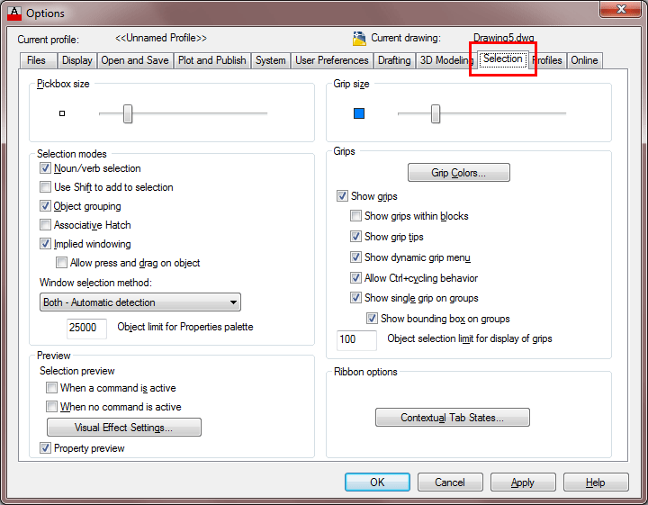

As you can see, you can customize a few things. Think about having a drawing that has a lot of blue lines in it. If you want, you can change your grip color so that they are clearer. Some people like a larger pickbox size, but I prefer a smaller box that is more precise. Another option that is used a lot is "Enable grips within blocks" - you'll learn about grips and blocks in later lessons.

LESSON 1-6: ASSIGNMENT 4 MODIFYING COMMANDS
Topics covered in this Lesson:
- Move
- Copy
- Stretch
- Mirror
In this assignment you will be adding some more common commands to your collection. All of these commands are ones that you will use on a regular basis.

Command | Keystroke | Icon | Location | Result
Move | Move / M |  | Home > Modify > Move | Moves an object or objects
Copy | Copy / CP |  | Home > Modify > Copy | Copies object(s) once or multiple times
Stretch | Stretch / S |  | Home > Modify > Stretch | Stretches an object after you have selected a portion of it
Mirror | Mirror / MI |  | Home > Modify > Mirror | Creates a mirror image of an object or selection set

This is a short assignment to show you how these commands are used. You will recreate the drawing called Assignment #4.
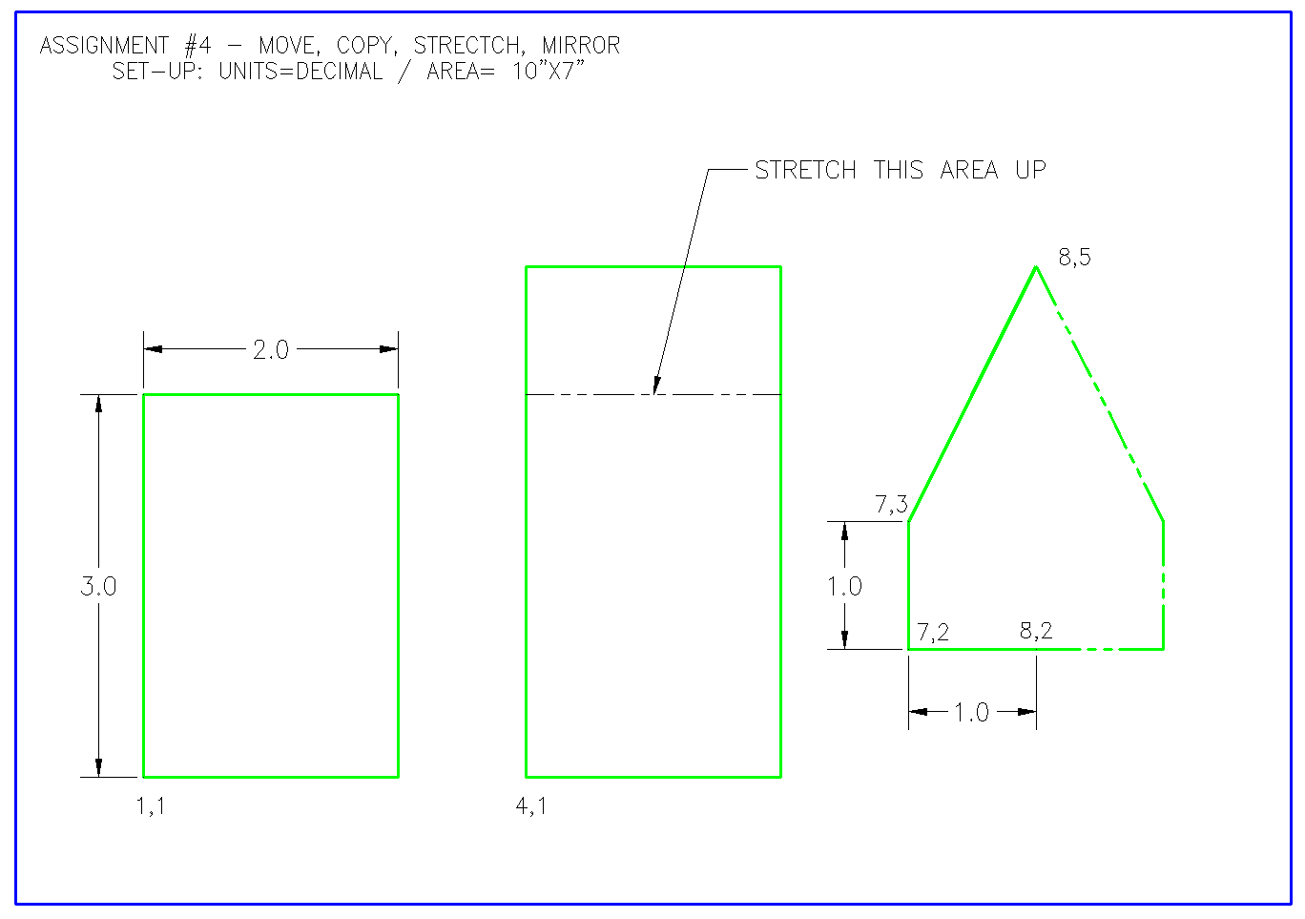
Start up AutoCAD and set up your drawing as you have in the previous assignments.
Turn on your Endpoint Osnap.
This time draw the border first. Draw a 10" wide by 7" high rectangular border using any method. The bottom left corner must be at 0,0
Draw a 2 wide by 3 high rectangle using the RECTANGLE command. The bottom left corner must be at 0,0
Notice that the small rectangle and the border are overlapping each other at the bottom left of your drawing. What you want to do is move the small rectangle right 1 unit and up 1 unit so that it is away from the border.
To do this, start the MOVE command by typing in either M or MOVE <ENTER>. Select all the lines of the rectangle using one of the selection methods described earlier. Press <ENTER>. Now AutoCAD asks for a "base point or displacement". What it is needing is a reference point. Click on the bottom left corner of the rectangle. AutoCAD now asks for a 'second point of displacement'. What it needs to know now is how far you want to move it. This is a great time to use relative coordinates. In this case, you want to move it 1" over and 1" up. So type @1,1 <ENTER> to achieve this. The rectangle will automatically move to its new location.
Now you want to copy this rectangle 3" over to the right. The copy command is very similar to the move command. (The only difference is that the copy command leaves an original behind.)
Start the COPY command. You will be asked to select objects. Select the rectangle you just moved. AutoCAD now needs the "base point or displacement" just like in the move command. Once again, select the bottom left corner of the rectangle. Once you've done this, you need to tell AutoCAD what the second point of displacement is. Since you want to move the rectangle over 3" to the right, type in @3,0 <ENTER> The rectangle has now been copied 3" over.
But the rectangle is not as tall as the one in the sample drawing, the sample drawing's rectangle is 1 unit taller. To modify this, you'll use the stretch command.
Start the STRETCH command by typing S <ENTER>. AutoCAD now makes you select objects by using a crossing window or crossing polygon. You're going to use a crossing selection. Remember from the Lesson 1-5 that you make a crossing selection by creating it from the right to left. Left-click just a bit above and to the right of the top right hand corner of the new rectangle (P1). Move your crosshairs down and to the left until your (dotted) crossing window covers the top half of the rectangle completely and then left click again (P2). You'll see that the objects are highlighted now. Press <ENTER> to accept this. Next you're asked for that now familiar base point. Pick on the top left corner of the rectangle. Now give AutoCAD the second point of displacement. In this case, you want to stretch the rectangle 1" up, so type @0,1 <ENTER> to do this. The rectangle is now 1" taller.
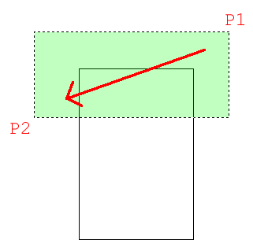
The goal when selecting objects to stretch is to draw the window over the vertices or points that you want to stretch. If you miss a corner, you will change the shape of the rectangle. So always be aware of which points need to be stretched. In this example, it was pretty obvious, in more complex drawings - it won't be.
Next you want to draw the polygon on the right side. To do this, you will draw the three lines on the left side first and then mirror those lines over to the right side. Draw the 3 lines any way you like (hint: use absolute coordinates.).
Once they are drawn, begin the MIRROR command. Select the three lines (press <ENTER>) Now you are asked for the first point of the mirror line. With your endpoint Osnap turned on, pick the end of the line at 8,2. Now you are asked for the second point. Select the point on the line at 8,5. Once you've done this, AutoCAD wants to know if you want to delete the old objects. In this case you don't, so accept the default by pressing <ENTER>. The mirror line will be half-way between the object the you are mirroring and where you want it to be. Figuring out where the mirror line is the toughest part of this command.

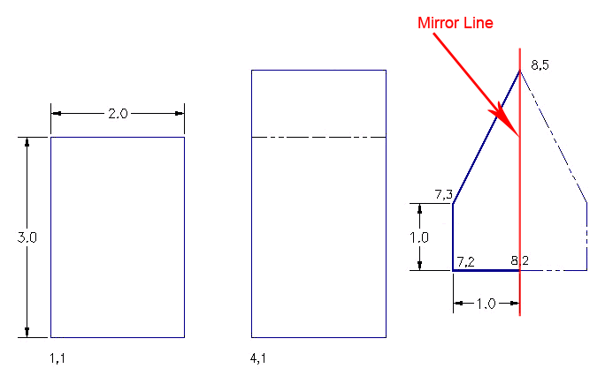
Command: MI MIRROR
Select objects: <SELECT THE 3 LINES> Specify opposite corner: 3 found
Select objects: <ENTER>
Specify first point of mirror line: <SELECT 8,5>
Specify second point of mirror line: <SELECT 8,2>
Erase source objects? [Yes/No] <N>: <ENTER>
The assignment is now complete. Review what you have done and practice on these commands. Save and print your assignment. Copy and Move are very common commands. For example, you might create a ceiling light, then have to move it into place, and then copy it to other rooms. Fortunately, these commands work very similar, and once you master one, you have mastered both.

LESSON 1-7: ASSIGNMENT 5 MODIFYING COMMANDS

Topics covered in this Lesson:
- Rotate
- Fillet
- Chamfer
- Array
Now it's time to learn a few more commands. Like all of the commands learnt so far, these too will be ones that you will use regularly.
Here are the commands that you will be learning in this lesson.
Command | Keystroke | Icon | Menu | Result
Rotate | Rotate / RO |  | Home > Modify > Rotate | Rotates objects to a certain angle
Fillet | Fillet / F |  | Home > Modify > Fillet | Creates a round corner between two lines
Chamfer | Chamfer / CHA |  | Home > Modify > Chamfer | Creates an angled corner between two lines
Array | Array / AR |  | Home > Modify > Array | Creates a repeating pattern of the selected objects
Once again you will recreate a drawing. This one is called Assignment #5.

Follow the steps shown carefully. As these commands require a little more input, make sure that you keep an eye on the command line. You will be asked to provide information throughout the commands.
Start up AutoCAD and load the acad.dwt template like you have for the other lessons.
Start by drawing a horizontal 10" X 7" border with the bottom left corner at 0,0
Draw a rectangle 1" wide by 3" tall with the bottom left corner at .75,.75
You are now going to rotate this rectangle 90° clockwise.
Start the ROTATE command. AutoCAD asks you to select objects. Select all parts of the rectangle and press <ENTER>. Now you must indicate a 'base point'. Think of this as a pivot point around which the rectangle will rotate. In this example, you want to select the bottom right corner (remember to use your Osnap). Once you've selected the base point, the command line shows rotation angle or [Reference]: This means that 'Rotation angle' is the default, so type in the angle you want to rotate the object. Think about how AutoCAD measures angles. Looking at your rectangle and the one on the assignment sheet, you'll see that you want to rotate the rectangle clockwise or: -90 degrees. Enter that number and press <ENTER>.
Command: RO <ENTER>
Current positive angle in UCS: ANGDIR=counterclockwise ANGBASE=0
Select objects: <Select the Rectangle> 1 found
Select objects:<ENTER>
Specify base point: <PICK BOTTOM RIGHT CORNER OF THE RECTANGLE>
Specify rotation angle or [Reference]:-90 <ENTER>
The rectangle is now been rotated -90 degrees from its original position. Picking different base points will give you different results. Undo the last command. Try a few different combinations of base points and angles to see what results you get. When you are done practicing, get the rectangle back to the position that it needs to be in.
Make a COPY of the rectangle 2" above the first one (remember your relative coordinates).
Now you're going to modify the second rectangle so that it has rounded corners. Start the FILLET command. Look at the command line. It will look something like this:
Command: F <ENTER> FILLET
Current settings: Mode = TRIM, Radius = 0.0000
Select first object or [Undo/Polyline/Radius/Trim/Multiple]:
AutoCAD first shows you what the current fillet radius is (0.0000). This will be the last value that was used. Once it's changed, it will keep the new value in memory. The next line shows you what options you have in this command. Remember that the Capitol of each option selects that particular option. What you want to do is change the fillet radius to 3/8" (or .375). To do this you have to type R <ENTER>. When you type this, AutoCAD will give you the chance to enter a new fillet radius. At this point enter .375 and press <ENTER>.
The fillet radius is now .375 (which is what you want). The default option is Select first object. Select the left side of the top rectangle (yes, the whole rectangle will highlight if you drew it as a rectangle). AutoCAD now asks you to select second object. Select the top line and AutoCAD will make a smooth round corner with a radius of .375. AutoCAD automatically ends the command at this point.

Copy the first rectangle to a point 4-1/2" above. Now you will use the chamfer command to give this rectangle sharp, angled corners.
Start the CHAMFER command.
This is very similar to the fillet command. You have several options available. Want you want is an even 45 degree angle 3/8" in from the corner. Like the fillet command, you first have to tell AutoCAD what distance you want. To do this, type D to select the Distance option. The command line now looks like this:
Specify first chamfer distance <0.5000>:.375<ENTER> as your first distance.) The command line now asks for the second distance. AutoCAD will automatically change the default of the second distance to match the distance you entered for the first.
Specify second chamfer distance <0.3750>:<ENTER>
You will then be asked to Select first line. The chamfer command works just like the fillet command. Select the line on the left of the top rectangle. (Don't worry if the entire rectangle highlights.) When prompted to Select second line: select the top line. You will now have a perfect sharp corner at a 45 degree angle 3/8" in from the corner. Do this to the rest of the corners.
Look at the command line. It should look like this:
Command: CHA <ENTER> CHAMFER
(TRIM mode) Current chamfer Dist1 = 0.0000, Dist2 = 0.0000
Select first line or [Polyline/Distance/Angle/Trim/Method]: D <ENTER>
Specify first chamfer distance <0.5000>: .375 <ENTER>
<0.3750>:<ENTER>
Select first line or [Undo/Polyline/Distance/Angle/Trim/mEthod/Multiple]: <select one side of the rectangle>
Now look at the assignment sheet and notice the group of six rectangles on the bottom right. You could draw each one individually, but AutoCAD has a command that will allow you to draw one, and it will make the others.
Draw a rectangle that is 1/2 unit square with the bottom left corner at 6,1.5 (absolute points).
Command: AR ARRAY
Select objects: <SELECT THE RECTANGLE> 1 found
Select objects: <ENTER>
Enter array type [Rectangular/PAth/POlar] <Rectangular>: <ENTER>
Type = Rectangular Associative = Yes
Select grip to edit array or [ASsociative/Base point/COUnt/Spacing/COLumns/Rows/Levels/eXit]<eXit>: COL
Enter the number of columns or [Expression] <4>: 3
Specify the distance between columns or [Total/Expression] <0.7500>: .75
Select grip to edit array or [ASsociative/Base point/COUnt/Spacing/COLumns/Rows/Levels/eXit]<eXit>: R
Enter the number of rows or [Expression] <3>: 2
Specify the distance between rows or [Total/Expression] <0.7500>: .75
Specify the incrementing elevation between rows or [Expresson] <0.0000>: <ENTER>
Select grip to edit array or [ASsociative/Base point/COUnt/Spacing/COLumns/Rows/Levels/eXit]<eXit>: <ENTER>
As you can see, it's a lot to enter, but this command can be a real time saver if you have lots of objects in your array.

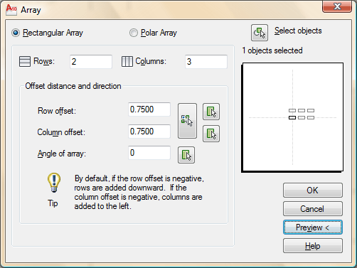

When confronting a new dialog box, I recommend that you look for what is needed from the TOP DOWN to the bottom. This is a great example.
- Choose the radio button for "Rectangular Array". This will array the object in a row/column arrangement.
- Next select the object you want to array, by picking on the button in the top right corner. (Press enter when done)
- Enter the number of rows (going across the page) and column (running up and down the page).
- Enter the Row offset. This is this from the bottom left of the original rectangle, to the bottom left of where the first copy will go.
- Enter the Column offset
- Pick the Preview button to see the array before committing.
Pick or press Esc to return to dialog or <Right-click to accept array>:
If the array is correct (check the sample drawing), press right click. If you need to change anything, press the ESC button, make your changes in the dialog box and preview again.
Now you are going to use the ARRAY (polar) command to create the shape in the top right corner of the assignment.
Start by making a CIRCLE with a center point of 7.5,5.5 and a diameter of 1.5 Next make a LINE from the center of the circle going 1" to the right (remember your relative input and Osnaps).
Start the ARRAY command. When asked to select objects, pick the line you just drew.
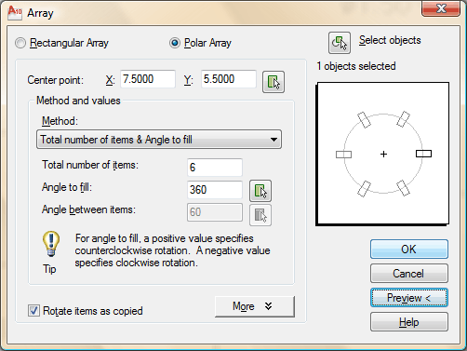
Examine the dialog box above. Remember to start from the TOP. In this case, you have to select your objects and select a Center Point for the array. (Select the center of the circle.)

LESSON 1-8 :ASSIGNMENT 6 LAYERS / DIMENSIONING / TEXT / SCALE
Topics covered in this Lesson:
- Layer,
- Text,
- Dimensioning,
- Scale
Now that you've learned a lot of the drawing and modifying commands, it's time to go to the next level. This lesson will introduce you to text, dimensioning and the concept of layers. Without dimensions you can not communicate what size your objects are. Is it a real house or a doll house? Text is used to convey information that is needed other than size - materials, manufacturing process, part numbers, etc.
What you will do is take one of your previous assignments, save it to a new name and then add text and dimensions to it. These are the commands you'll be learning.

Command | Keystroke | Icon | Location | Result
Layer | Layer / LA |  | Home > Layers | Starts the Layer and Linetype property dialog box
Text | Text |  | Home > Annotate > Single Line Text | Creates a single line of text
Dimension | Dim | Many | Home > Annotate > Dimension > (pick one) | Dimensions previously drawn objects
Scale | Scale / SC |  | Home > Modify > Scale | Proportionately resizes (or scales) objects

Begin by opening up Assignment #5 from your CAD folder.
Using the SAVE AS option, immediately save it under the name Assign6.dwg
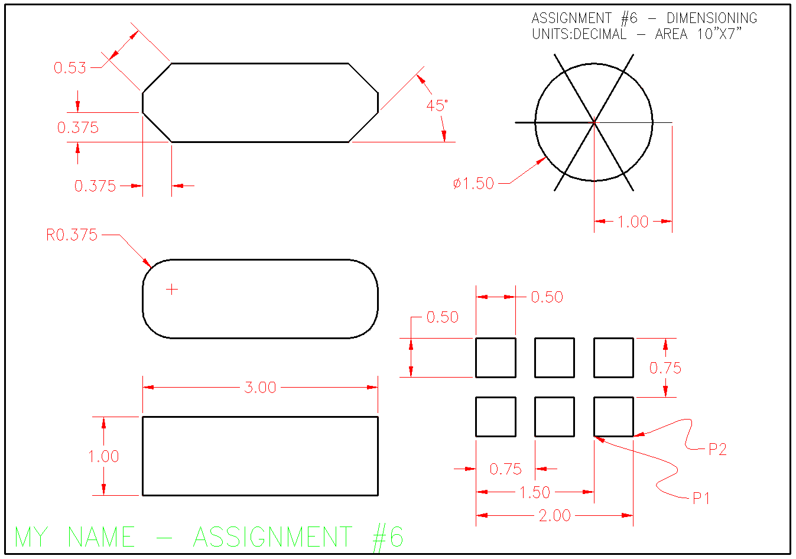
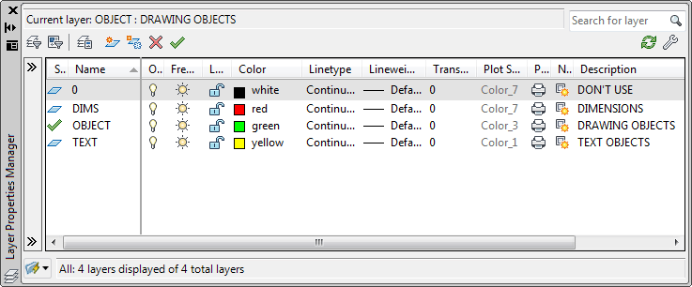
The first thing you want to do is create three layers. Layers are used to organize drawings. Imagine a large project for a high-rise tower. The designers would create layers for the electrical, plumbing, landscape and more. It is necessary to control the drawing and turn some layers off and view only the ones you want. This is one reason why layers are needed. When you go on to use AutoCAD professionally, every drawing you deal with will have layers.
You will be creating a layer for the dimensions, one for the objects (lines that were drawn) and another for the text. Start the LAYER command (LA). This will bring up the Layer Properties Manager Palette (shown below). We'll cover the things that are used in this lesson.

Looking at the Dialog Box, you will see a lot of information.
From left to right, this is what the columns are for (not everything is used in this level).
COLUMN | DESCRIPTION
Status | This column has a green check to indicate the current layer (all new objects will be drawn on that layer). Double click here to make the layer current.
Name | Give the layer a good, descriptive name (but not too long)
On | Turns the visibility of that layer on (visible) or off (invisible)
Freeze | Similar to 'On', but can be used in Viewports (later tutorial)
Lock | Retain visibility, but disable modifying objects on the locked layer.
Color | Used to select the color for objects drawn on each layer
Linetype | Used to select the linetype for objects drawn on each layer
Lineweight | Used to select the lineweight for objects drawn on each layer
Plot Style | Plot styles are used to define how objects are plotted - this can be different from the properties described above.
Plot | Set the layer to either plot (on) or not (off)
New VP Freeze | When on, it will freeze the selected layer in new viewports when they (viewports) are created
Description | Use this to give a description to your layer system - very important when working with other users.

Now you have the dialog box on your screen, click the 'New' button . This will create a new layer and give you an opportunity to name it. Name this layer TEXT. Click on the small box towards the right and select yellow for the color. Create another layer and call this one DIMS (for dimensions), and make its color red. Finally, create a third layer and call it OBJECT and make its color green. You have just created three new layers in your drawing. Highlight the TEXT layer and then press the 'Make Current' button . This makes the TEXT layer current and anything you draw will be placed on that layer. Your Dialog box should look like the one above. If it does, press OK to close the dialog box.
Now that you have your layers, select all your objects and then look for the layer tool panel. There is a droplist there with all of your layer names. With your objects selected, change the layer to OBJECT. If all went well, your lines and circles will now be green and on the object layer.
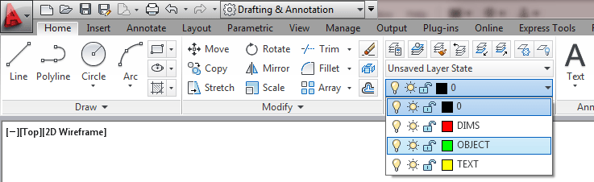

ADDING TEXT
A later tutorial will discuss text in more detail, but for now see what is involved in adding text. TEXT is your current drawing layer now, so what you will be doing is creating some text now. Type in TEXT on the command line. Look at the command line.
Command:TEXT
Justify/Style/<Start point>:
The first thing AutoCAD wants is a starting point for the text. Type: 0,0 to place it at the bottom left corner of your drawing. Notice that there are other options you could make, but ignore them for now.
Height <0.2000>: <ENTER>
Next, AutoCAD wants to know how tall you want your letters to be. For this assignment, you want them to be 1/4" tall. Type in .25 at the Height prompt.
Rotation angle <0>: <ENTER>
One more thing before you start typing in text, tell AutoCAD if you want to have your text rotated. Not this time, so press <ENTER> to accept the default of 0 degrees.
Text: (YOUR NAME - ASSIGNMENT #6)
Finally you can type in what you want to put on the drawing. At the prompt, type your NAME and ASSIGNMENT #6 then press <ENTER>.
You will see that AutoCAD has placed your name in the bottom left corner at 1/4" high and in yellow on the 'Text' layer.
You don't really want your name jammed into the corner like that so move it up and over 1/8" (Remember your MOVE command and relative points : @.125,.125)

Now it's time to start dimensioning your drawing. Bring up the Layer dialog box and make DIM your current layer.
This is one time when I recommend to use the icons. Dimensioning is A LOT easier this way. If you don't see your dimensioning toolbar on the screen, right click on one of your toolbar icons and check the Dimension checkbox. You'll see the toolbar appear. Close the Toolbars dialog box.
There are several different types of dimensions, here are the ones you'll be using in this lesson (Each of the dimensioning icons gives you a quick clue as to which type of dimension it will create.) The image below shows you the standard dimensioning icons. This list below shows you which dimension types are available on the Dimension tool panel.
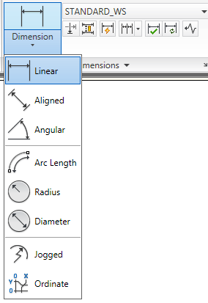

Here are the ones you'll be using in this lesson.
Linear dimensions are used for dimensioning either horizontal or vertical distances.
Aligned dimensions will measure the actual length of an angled line.
Radius dimensions will give you the radius of either arcs or circles.
Diameter dimensions are used on circles.
Angular dimensions will measure the angle between two lines that you pick.
Baseline dimensions are a special type that will automatically stack dimensions along one plane as you pick points.
Once you have your objects drawn, you need to go to the menu at the top of the screen and click on Annotate. This will show the Dimension tool panel as well as the text panel and others.
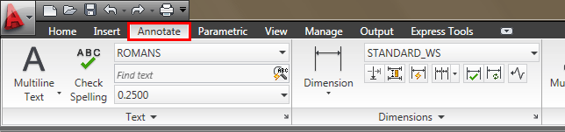
The type of dimension you pick will depend entirely upon what information you want to convey to the person reading the drawing. Look at the sample drawing and pick out the different types of dimensions and where they are used.
We'll start with the most common (and easiest): Linear Dimensions. You'll use this type to add dimensions to the rectangle in the bottom left of your drawing. Pick on the icon and then look at the command line.
Command:_dimlinear
Specify first extension line origin or <select object>:
It asks for either the origin of the first dimension line (a starting point) or you can press <ENTER> to select a particular line. Turn your OSNAPS on to endpoint only. Pick the top left corner of the rectangle. AutoCAD then asks for the second extension line origin. Pick the top right corner. You'll then see the dimension appear and AutoCAD asks for the Dimension line location. Pick somewhere just above the line where you think it fits well.
AutoCAD then shows you the length that it found to be the length of the line you just dimensioned. The following lines show what you should have seen on your command line:
Specify second extension line origin:<SELECT TOP RIGHT CORNER>
Specify dimension line location or
[Mtext/Text/Angle/Horizontal/Vertical/Rotated]:<PICK ABOVE THE LINE>
Dimension text = 3.000
Now dimension the line on the left side using the same method.
Now you want to dimension the radius of the fillet on the object above the first box. Pick the icon for radius dimension. AutoCAD asks you to select an arc or circle. Pick the arc on the top left corner. Again AutoCAD then wants you to pick the dimension line location. Pick anywhere outside the arc where the dimension fits well.
Looking at the top left object on the sample sheet, notice that there are a few ways to dimension the corners. Start on the bottom left. Pick the Linear Dimension icon. Instead of picking the two endpoints, press <ENTER> and AutoCAD will ask you to select the object you want to dimension. Pick on the angled line in the bottom left corner. As you move your cursor around, you'll see that you could place it either to the left or below the line. Choose one or the other and place your dimension. Repeat these steps to add the other dimension.
At the top left, you want to add an Aligned dimension. Pick the icon for this. As with the linear dimensions, you can either pick the endpoints or press <ENTER> to choose and object. When you're asked to place the dimension, you'll see that you can only move parallel to the line that you picked. Place the dimension line somewhere outside the object.
Now you're going to dimension the angle on the bottom right corner of the top box. Pick the Angular dimension icon. Pick the bottom line and then the angled line in the bottom right corner. Place the dimension so that it looks like the one in the sample.
Now its time to dimension the circle. Pick the icon for the Diameter dimension. AutoCAD then wants you to select the arc or circle. Pick anywhere on the circle. Then you have to place the dimension line somewhere. Pick a good spot for it.
Dimension the 1" line in the circle as shown using a linear dimension.
Dimension the top left box of the array as shown using Linear dimensions.
Dimension the space (0.75) between the two rows by picking the endpoints of the lines.
Dimension the space (0.75) between the columns as shown.
Now for the tricky part. You want to add baseline dimensions to the column distance dimension you just created. Pick the icon for the baseline dimensions. Look at the command line:
You may be asked to select the base dimension. If so, pick on the 0.75 dimension for the column. Then you're asked to Specify a second extension line origin. Pick where P1 shows you on the sample drawing. AutoCAD then will get you to keep repeating this process until you press <ENTER> to end the command. Pick near P2 to continue, then press <ENTER>. This is what your command line should have looked like:
Command: _dimbaseline
Select base dimension:
Specify a second extension line origin or (Undo/<Select>): <pick P1>
Dimension text = 1.50
Specify a second extension line origin or (Undo/<Select>): <pick P2>
<Dimension text = 2.00
Specify a second extension line origin or (Undo/<Select>): <ENTER>
Your drawing should now look similar to the sample drawing. Check to see if you missed any dimensions.
Now you have dimensioned the drawing, save it and print it.
Next you want to copy everything over 12" to the right. Start the COPY command, and when asked to select objects, type ALL <ENTER>. Then copy it all 12" to the right.
What you want to do next is scale the copy of everything to double its existing size. Start the SCALE command. When asked to select objects, draw a window around the new set of objects and press <ENTER>. When asked for a base point, pick the bottom left corner of the border. Enter 2 for the scale factor. Your command line should look like this:
Command: SC <ENTER>
SCALE
Select objects: Other corner: 38 found
Select objects:<ENTER>
Base point:<Pick the Bottom Left Corner>
<Scale factor>/Reference: 2 <ENTER>
Perform a Zoom Extents (Z <ENTER> E <ENTER>) at the command line. Now that everything is twice as large, Zoom in on your dimensions and you'll see that they have automatically adjusted to the new sizes! This is called associative dimensioning.
There are many different parameters you can change to get just the right look for your dimensions and text (use the DDIM command). This is will not be covered in this course.
For practice, you can try dimensioning some of your other assignments.
Even if your drawing is 100% accurate, it is still only as good as the dimensions. Some common mistakes when dimensioning are:
- Not using your Osnaps. If you don't get the exact endpoint of a line, then your dimension is wrong.
- Snapping to the wrong point. In detailed drawings, this can be easy to do if you aren't paying attention.
- Incomplete dimensions. If you miss one or two dimensions, you can delay the project while these numbers are located, new drawings made, delivered, etc..
- Confusing dimensions. Make sure that your dimensions don't overlap, or aren't too close, or otherwise unclear.

LESSON 1-9 DIRECT DISTANCE ENTRY AND OBJECT TRACKING
Topics covered in this Lesson:
- Direct Distance Entry
- Polar Tracking
- Object Snap Tracking
- Dynamic Input

Direct Distance Entry
As mentioned earlier in the lessons, there are many ways to do things in AutoCAD. To enter distances, you have been shown Absolute, Relative and Polar Coordinates. I've spent the previous 8 lessons showing you foolproof ways to enter data (the hard way). Now you will be shown four more ways to tell AutoCAD where the locate the point you are drawing to (the easy way).
DO NOT FORGET THE BASICS OF MANUAL ENTRY
Direct Distance Entry (or DDE) is a way of bypassing the usual ways of entering in coordinates. and just entering the distance.
The method is quite easy.
Make sure that you have set Ortho (locking your input to vertical and horizontal) by pressing the F8 button and checking to see that the "Ortho" button is depressed (blue) on the status bar like this:
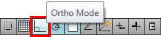
Your F8 key will toggle Ortho on and off.
Lets say you want to draw a line from one point directly to the right 10 units.
Start the Line command and click on the screen anywhere, then more your cursor to the right of that point. If Ortho is turned on, the line should only point directly to the right and not at an angle. Now type in 10 <ENTER>. Press <ENTER> again to exit the command. You now have line that is 10 units long.
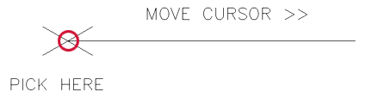

That is a very easy way to draw line segments. If Ortho is not set, your drawing will get messed up very quickly and will not be easy to fix. I have seen too many students take this easy route and destroy their projects, fail the class and become homeless. So don't do this.
Polar Tracking
Now wouldn't it be cool to draw angled lines (like the short ones in the above image)? Well you can, but first you have to make change in your settings.
Type in DSETTINGS and you get the Drafting Settings dialog box, go to the "Polar Tracking" tab. :
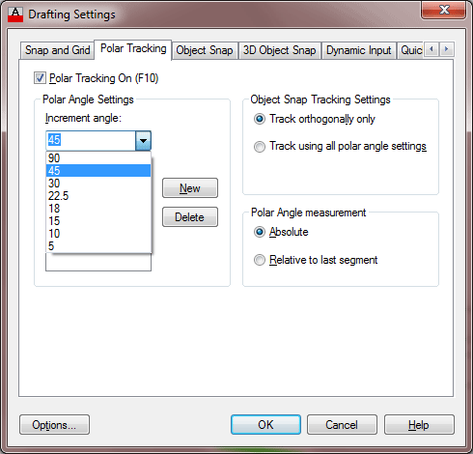

Then make sure that Polar Tracking is On 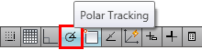 (press your F10 key to toggle it on and off) and then select the increment angle. I recommend using polar settings with 45° increments unless you specifically need something else.
In the example above, I made 4 lines 1 unit long using Direct Distance Entry (DDE). See if you can duplicate this on the left end of the 10 unit line you just drew. The process is the same as you did for the DDE of the previous line. Make sure your increment angle is 30° and draw a line 1 unit long using DDE.
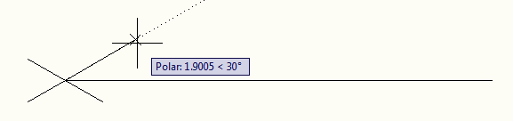
You can not have Ortho and Polar Tracking on at the same time. As you start to draw more, you will see that these two features are great time savers. There will be times, though, when you have to use absolute and relative coordinate entry (especially in 3D).
Refer back to the assignment in Lesson 1-2 and draw using the methods shown in this lesson.
Now I'm going to repeat this one last time:

Object Snap Tracking
Now you've just seen how you can find distances from points and measure accurately, but what if you want to find specific points based on previously drawn objects? You can use Osnaps, but they don't always find the point you need.
Consider that you want to draw a circle in the middle of a rectangle like the example below:
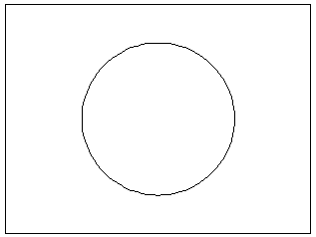
In the olden days, you would have drawn a line from opposite corners of the rectangle to find the middle, then snapped to the midpoint of that line for the circle's center point, drawn the circle and then erased the reference line.
Now you can use object snap tracking. This is a way of finding reference points and drawing from them. To do this exercise, make sure that your Midpoint Osnap is on.
Draw a RECTANGLE from 0,0 to 4,3
Make sure that the Object Snap Tracking and Osnap button are depressed. 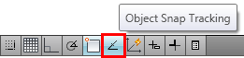
Start the CIRCLE command.
Move your cursor over the midpoint of the bottom line of the rectangle. You should see a light dotted line project vertically through your cursor. Now more your cursor to the midpoint of the right vertical line of the rectangle. As you move your cursor towards the center of the rectangle, you should see the 2 dotted lines cross. It should look like this:

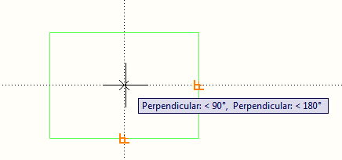
Once you see both lines, you can pick and the center point will be exact center of the rectangle. Give your circle a radius of 1".
This is a very simple example, but as you start drawing more complex shapes, this will be a handy to tool to master, and a great time saver. Object tracking will work with any Osnap that is invoked. But always check to make sure that you are picking the point you want.
Now the fun begins! You can combine Object Snap Tracking with Direct Distance Entry. What if you want to draw a line that starts 10 units above the top right corner of a rectangle? You can just use these techniques in tandem to move up from the corner and and type in 10 to get the starting point.
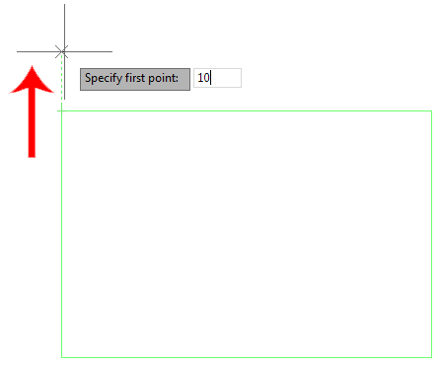
This technique is a great time saver. In older versions, you have needed to offset the rectangle, draw the line and then erase the rectangle. Try this out on your own.
Dynamic Input
Now it's time to put all these concepts together and combine them with on-screen help that's called 'Dynamic Input'. In older versions of AutoCAD, users relied solely on the command for information. Later versions of AutoCAD added Dynamic Input to put a user's keystrokes in the drawing area near their cursor.
Turn on Dynamic Input by clicking on the status bar (toggle with F12):
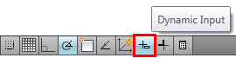 Now when you draw, you will see all kinds of information on the screen.
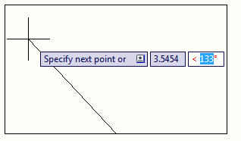
In this example, I have drawn a line starting at the midpoint of the bottom line going up 20.5 units (which I manually entered) at 135°. Once I enter the distance, I can press the Tab key to switch over to the Degrees and enter a value there. I could also have typed @20.5<135 using relative coordinates. By default you are in the first field (length) - press the TAB button on your keyboard to be able to enter the angle.
If you are new to AutoCAD, I recommend turning this feature off as it takes your eyes off the command line (which will prompt you for information).
To review, AutoCAD provides some nice tools to enhance your productivity. Use them, master them, but don't forget the basic of inputting points. Especially when you do 3D work, manual entry becomes valuable.

LESSON 1-10 :CHANGING THE PROPERTIES OF OBJECTS

Topics covered in this Lesson:

Object Properties
Now that you have learned how to draw objects and modify them using special commands, you need to know more ways to change the properties of an object. For instance, you may have made a spelling mistake in your text. You could erase it and re-create it, or you could double-click on it and just correct the error. Maybe you drew something on the wrong layer? This process is an extremely important tool to help you with your CAD work.
DON'T REDRAW AN OBJECT - CHANGE ITS PROPERTIES
There are a few ways to change, or view an objects properties. First is by using the PROPERTIES command.

Command | Keystroke | Icon | Location | Result
Properties | PROPERTIES /  PR / CTRL+1 | No Icon | Home > Properties | Displays the properties of the object in the Properties Palette
Match Properties | MATCHPROP / MA  PAINTER |  | Home > Clipboard > Match Properties | Copies the properties from one object to another

The method is quite easy and also the most complete way of viewing properties.
Draw a line from (any point) to (any point) and press <ENTER>. This is only time I will not tell you to use specific coordinates. :)
Now select the object by clicking on it and pick the properties icon. Once you do this, you should see the properties palette appear showing everything that makes that line what it is.
What you see here is the complete palette. Before you look at the properties, take a moment to examine the palette itself. These are new to later versions of AutoCAD. Since it takes up a large amount of the screen, you have the option to either close it completely ('X' at the top) or collapse or hide the palette (below the X) for future reference. You can also dock a palette to the side of the screen. Try the buttons out and then continue reading.
Now look at the properties as displayed in the palette. At the top are the 'General' properties - these are common to all AutoCAD objects (they all have them). You will see that one endpoint of the line is shown as the "Start X" and "Start Y" points (X,Y point). If you want to change the location of the X coordinate for the Start point, pick in the text area, type a number and press (ENTER). You also have the option of picking new X coordinate with the small icon shown above.
Have good look at the palette. Erase the first line, draw another line and then display the new line's properties. You should see different numbers.
Now erase the line and draw a circle. Display the properties and you will see different fields. You will see that the the Start X point has been changed to "Center X". The properties displayed are specific to the object you have selected.
Now draw a line next to the circle. Select both by clicking on one, and then the other. Now display the properties by selecting the icon. You will now see a much short list of properties. This short list will include properties that are common to both objects, such as layer, color, etc.
Now try something different. Erase everything and close the Properties palette. Draw a circle and then select it. Right click on the screen and choose the Properties option at the bottom of the list as shown below:
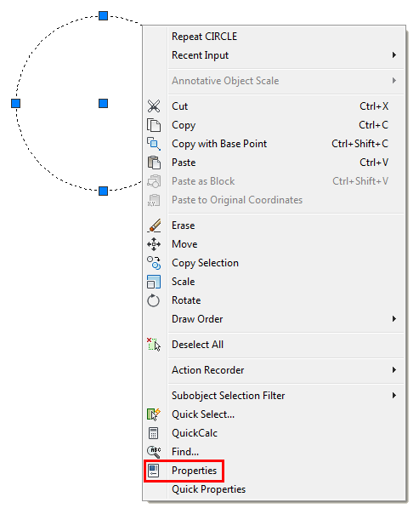
You'll see the same palette appear - in the same space where you closed it. You also have the choice of selecting Quick Properties the same way. If you do, this is the smaller palette that you will see (handy on smaller monitors).
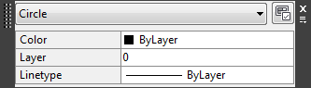

OTHER OBJECTS
By now you see how you can view and edit properties of objects you have drawn. Those the methods will work on any object. But what about other objects? Could there be easier ways to edit their properties? You bet!
Enter a line of text like you did in the Lesson 1-8. View the properties like you did in the previous examples. Note again, the various fields that in this case are unique to Text. Now try "Double-Clicking" on the text.
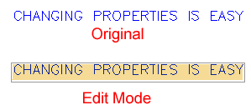
Now you can change the text and press <ENTER> (then <ENTER> to end the command). This is a much easier method to change the text's content, but none of the other properties. You could also have changed the text in the Properties palette, but this method is much quicker.

Changing Layers
Many times you will draw an object and find that is on the wrong layer. To change an object's layer, you can open the Properties palette (as shown above) or use this easy tip.
Create a new LAYER (as you did in Lesson 1-8) and call it LINES. Do not make it the current layer. Draw a line on the 0 layer.
Now select the object and then move your cursor up to the layer droplist. You'll see a list of all of your layers - pick on the LINES layer - then press ESC.
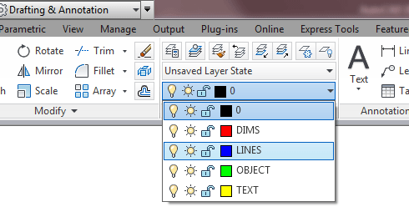
Now when you check the properties of the line, you'll see that it is on the LINES layer. This is one method you will be using a lot, so learn it and master it.

Match Properties
One of the easiest ways to set properties is to use the MATCH PROPERTIES command. This is used by starting the command (MA) and then selecting the source object (the one that has the desired properties) and then selecting the target object(s). Use can also select the source object first, then the icon and then the target object. The icon for this command is in the clipboard tool panel. And no, I don't know why it's not in the Properties panel.

Conclusion
You now have the skills to change to properties of any object you draw. There are many ways of doing it, but you'll see that some methods are easier. So remember, once something is drawn, you can modify it as shown in the previous lessons in this level, or modify the properties. In only rare instances, is it easier to erase and redraw the object. As you learn more commands in the next lessons, try these methods to see what can be changed - and how.

LESSON 1-11:ZOOMING AND PANNING AROUND A DRAWING

Topics covered in this Lesson:

Zoom | Pan
So far the tutorials have dealt with drawing and modifying objects. This lesson will be a primer on how to move around in your drawing. With simple drawings like the assignments in Level 1, you didn't have much need for moving around or zooming in your drawing. The more complex your drawing is, the more you will need to master the power of zooming and panning. Mastering these techniques will enable you to be more productive in your drawings and life will be better.
EFFECTIVE ZOOMING CAN DRAMATICALLY INCREASE YOUR SPEED
One single command will give you the versatility to move around your drawing. This is the ZOOM command. Another useful command is PAN. These are both quicker than using the scroll bars on the side of the drawing area, unless you have a very short distance to move your drawing (and can make your scroll bars obsolete and thereby create more drawing space)..
Start the Zoom command by typing Z <ENTER>. When you do this, you will see the following options on the command line:
Command: Z <ENTER> ZOOM
Specify corner of window, enter a scale factor (nX or nXP), or
[All/Center/Dynamic/Extents/Previous/Scale/Window/Object] <real time>:
Remember that to invoke any option, just type the capital letter of your choice. (e.g.: type: E <ENTER> for "zoom extents". The default is "Realtime" which you invoke by pressing <ENTER>. One by one, here are the options available to you. These icons are available on the View ribbon under the Navigate Tool Panel.
COMMAND OPTION
ICON
DESCRIPTION
Zoom
Extents

This option will display all the graphics that are contained in the drawing (referred to as the drawing extents) with the largest image possible.
Zoom
Window

This option (also a 'hidden' default) prompts the user to pick two corners of a box on the existing view in order to enlarge that area to fill the display.
Zoom
Previous

This option restores the displayed view prior to the current one. For the purpose of this option, up to 10 views are saved so that the last ten views can be recalled. This option includes every time you use the scroll bar, which is one reason to avoid the scroll bars for panning a lot in your drawing.
Zoom
Realtime

Zoom Realtime provides interactive zooming capability. Pressing <ENTER> (after entering zoom) on the command line automatically places you in Realtime mode. Hold the left mouse button down at the midpoint of the drawing and move the cursor vertically to the top (positive direction) of the window to zoom in up to 100% (2x magnification). Hold the left mouse button down at the midpoint of the drawing and move the cursor vertically to the bottom (negative direction) of the window to zoom out to100% (.5x magnification). You cannot zoom out beyond the extents of the current view.
When you release the pick button, zooming stops. You can release the pick button, move the cursor to another location in the drawing, and then press the pick button again and continue zooming from that location. To exit Realtime Zoom mode, press <ENTER> or (ESC).
Zoom All

This option causes AutoCAD to display the whole drawing as far as its drawing limits or drawing extents (whichever is the greater of the two).
Zoom
Dynamic

This is a very useful ZOOM option once it is understood. It permits very quick movement around the drawing. Once selected, this option redraws the graphics area of the screen and displays two rectangles. The larger box shows the extents of the current drawing. The smaller box shows the current view with an "X" in the middle. This moves with the mouse. This view box should be positioned so that its lower left corner is at the lower left corner of the view required. By pressing the left button on the mouse, the "X" is replaced by an "> " pointing to the right side of the view box. This allows you to change the magnification. As the mouse is moved, the view box shrinks and expands so that the size of the required view can be set. The left mouse button toggles between PAN "X" and ZOOM "> " mode so that fine adjustments can be achieved. When the view required has been selected, press <ENTER> or right click to cause AutoCAD to display it.
zoom
Scale

This is a 'hidden' default option. You do not have to type "S" to choose this option. It simply requires the entry of a number that represents a magnification factor. Note that the factor is applied to the entire drawing (as defined by the drawing's limits). Numbers less than 1 will reduce the displayed size of the drawing, while numbers greater than 1 will enlarge it. If "X" is inserted after the number (e.g.. 0.8x) then the factor is applied to the current view. If "XP" is inserted after the scale factor, then the view is scaled relative to paper space. This is useful for zooming a view within a paper space viewport to a specific scale, for example, "1/48XP" will produce a view of model space at a scale of ¼" = 1' relative to paper space.
Zoom
Center

This option requires two things: a point that is to be the center of the new display and a value to be its new height in drawing units. The existing height is the default for the new height to allow for panning across the drawing. If the new height value is followed by "X" (e.g.. 2x), then it is taken as a magnification factor relative to the current height. If followed by "XP", then it is taken as a scale factor relative to paper space and can be used for scaling the contents of paper space viewports.
Aerial View command: DSVIEWER
Obsolete in 2010 and newer
Aerial View is a zooming tool that displays a view of the drawing in a separate window so that you can quickly move to that area. If you keep the Aerial View window open as you work, you can zoom and pan without choosing a menu option or entering a command. You can change the view by creating a new view box in the Aerial View window. To zoom in to the drawing, make the view box smaller by left clicking a rectangle. To zoom out of the drawing, make the view box larger. As you zoom in or out of the drawing, a real-time view of the current zoom location is displayed in the graphics area. The screenshot shows how the view box looks. Right click in the box and you can move the box to where you want to zoom to.
Zoom
Object

This option asks you to select an object or objects, then press <ENTER> and the screen will zoom to those objects only. This is great for when you want to work on object.
Zoom In

Clicking this icon will zoom in to the drawing by about 50%. This option is only available as an icon and cannot be invoked by the command line.
Zoom Out

Similar to 'Zoom In' - this icon will zoom out of your drawing and allow you to see about 50% more of your drawing space.
Mouse Scroll
No Icon
If you have a scrolling wheel on your mouse, you can use it to zoom in and out of your drawing. Scroll towards you to zoom out and away from you to zoom in. You have the option to change the amount of zoom per wheel click with the Zoomfactor system variable. Keep in mind that you will zoom in and out using your mouse location as a 'center point'.

PAN
Panning allows you to quickly move around the drawing area at the same magnification you currently have set. Type in PAN (or P) <ENTER> and a hand will appear on the screen. Left click and hold to move around your drawing.

As you can see there are quite a few options. To begin with I would strongly recommend getting really good at these 3:
Use the Zoom > Extents whenever you want to see all objects.
Use the Zoom > Window option to 'close-in' on one area.
Use the Zoom > Previous option to return to where you were.
I generally use them in conjunction with each other. I'll do a zoom extents to see what state the drawing is at, then perform a Zoom Window to get to the area I need to work in, then do a Zoom Extents when I am done in that area. In between, I may need to use a combination of Zoom Window and Zoom Previous.
Additionally, using your mouse wheel to zoom can be very fast for moving in and out of an area - practice this technique as well.
The zoom command can also be invoked transparently. This means that you can start it up in the middle of a command. For example, if you are in the trim command and want to see a bit more of your drawing, just type 'Z (note the apostrophe) at the command line and you can then zoom using any of the available options. Press <ENTER> to get back to your command.
Also, right clicking while in the zoom command gives you options. Try this and see which choices are available with this.
LESSON 1-12
ORTHOGRAPHIC PROJECTION

Topics covered in this Lesson:

Orthographic Drawing Techniques in AutoCAD

Putting your skills to use.
So far in this level you have been learning the basic 2D AutoCAD commands. What you learned in this level will be a very large part of what you use in your daily drafting. This tutorial isn't going to teach commands, but will instead show a common technique that is used a lot in 'Mechanical" drafting. It will also ask you to think about what you are drawing, and how it needs to be represented.
Mechanical drafting is a field within the drafting world. In simple terms, it is used to describe the methods for drafting and designing machines, assemblies and in a nut shell, the 'parts' that used in everything from a fork to a Formula 1 race car. It doesn't include anything that involves buildings and structures (Architectural & Structural drafting) or landscapes and roads (Civil drafting and engineering).
Now just because you are dreaming of becoming an Architect, it doesn't mean that you should skip this tutorial. In fact, you will likely need to use these concepts or read diagrams related to this subject. So read on!

What is Orthographic Projection?
If you look at the image below, you will see a drawing for a part. It shows the object with a top view, a front view and a side view. You'll also see an Isometric view that is sometimes used to give a more visual look. This tutorial won't cover Isometric drafting as it is shown in Tutorial 3-2. Save your drawings that you do in this exercise for more practice in that lesson.

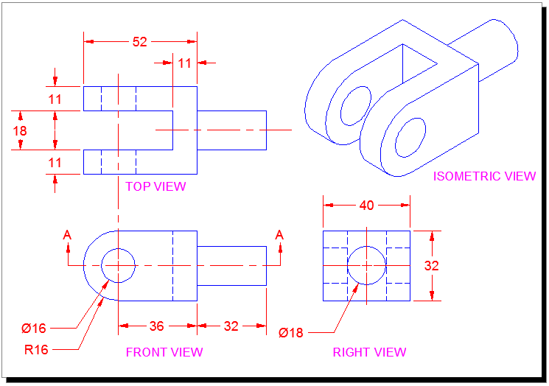
The reason that this method is used is that you can take a designed part, draw it, dimension it and then give all the needed information to the manufacturer.
In some cases only 2 views are needed, but for anything more than a simple part, 3 or more views are needed. Very complex parts will need 6 or more.
There are 2 methods of deciding what views are used and where they are placed in the drawing. I'll borrow some info from Wikipedia to show this

First-angle projection (European Standards)
In first-angle projection, the object is conceptually located in quadrant I, i.e. it floats above and before the viewing planes, the planes are opaque, and each view is pushed through the object onto the plane furthest from it. (Mnemonic: an "actor on a stage".) Extending to the 6-sided box, each view of the object is projected in the direction (sense) of sight of the object, onto the (opaque) interior walls of the box; that is, each view of the object is drawn on the opposite side of the box. A two-dimensional representation of the object is then created by "unfolding" the box, to view all of the interior walls. This produces two plans and four elevations. A simpler way to visualize this is to place the object on top of an upside-down bowl. Sliding the object down the right edge of the bowl reveals the right side view.
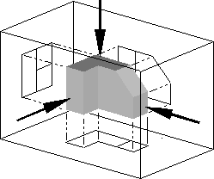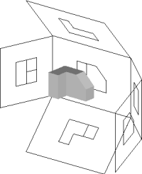

Image of object in box, with views of object projected in the direction of sight onto walls using first-angle projection. Similar image showing the box unfolding from around the object.

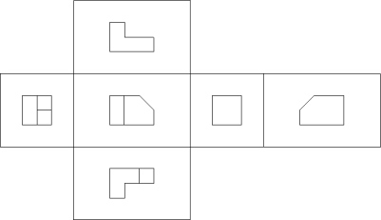

Image showing orthographic views located relative to each other in accordance with first-angle projection.

Third-angle projection (USA Standards)
In third-angle projection, the object is conceptually located in quadrant III, i.e. it lurks below and behind the viewing planes, the planes are transparent, and each view is pulled onto the plane closest to it. (Mnemonic: a "shark in a tank", esp. that is sunken into the floor.) Using the 6-sided viewing box, each view of the object is projected opposite to the direction (sense) of sight, onto the (transparent) exterior walls of the box; that is, each view of the object is drawn on the same side of the box. The box is then unfolded to view all of its exterior walls. A simpler way to visualize this is to place the object in the bottom of a bowl. Sliding the object up the right edge of the bowl reveals the right side view.
Here is the construction of third angle projections of the same object as above. Note that the individual views are the same, just arranged differently.
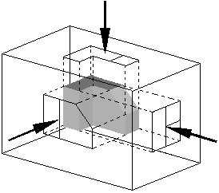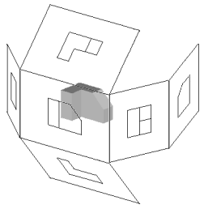
Image of object in box, with views of object projected in the direction of sight onto walls using first-angle projection. Similar image showing the box unfolding from around the object.

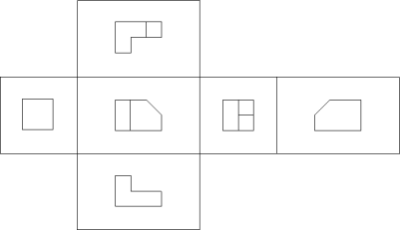
Image showing orthographic views located relative to each other in accordance with third-angle projection.
Ok - that was some fun theory - thank for reading it. One last bit of info before we get back to CAD stuff. Since there are 2 kinds of standards, how do you know which is which when you have a drawing in front of you? There is a standard symbol that is used in the title block to indicate which method was used.
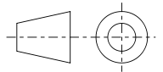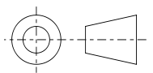
This symbol shows a simple cone and displays the projection. Think about which symbol represents which method, then move your mouse over the images to see if you were correct.
Because I am in North America and was trained to use the "Third Angle Projection" method, that is what I will show in this tutorial. The techniques for drawing are the same, it's just a matter of which direction you 'project' or draw the lines.

Drawing 3 View Orthographic Projection
For these exercises, we'll start by looking at an Isometric drawing of an object and then draw the Front, Side and Top views using the dimensions we're given. In the workplace, you might find that you are given a part to measure and then draw, or you might be designing the part yourself.
Here's the part that we'll draw in this tutorial:
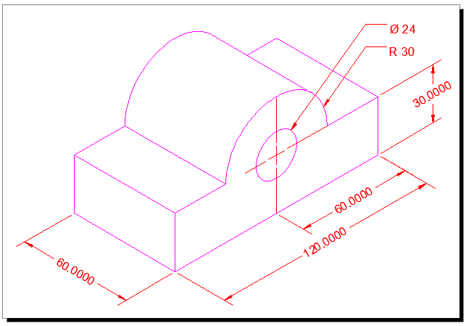

This is a very simple example to get you used to the concepts. You'll have more practice exercises at the bottom.
Ok, the first question that you'll ask yourself, is "Where do I start?". I recommend that you start where you have the most information. This will sometimes be the front or the top - it depends upon each drawing. In this case, I will start with the front and draw it.
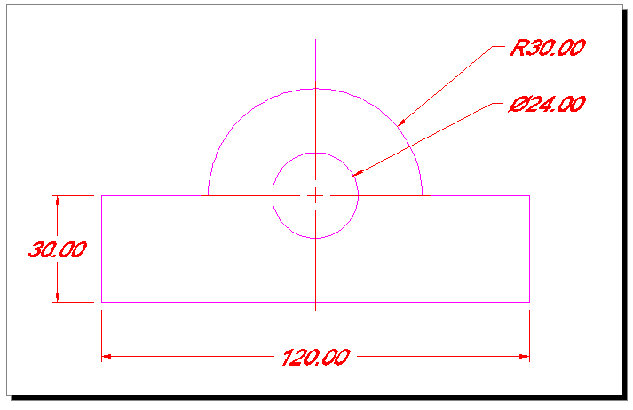
You don't need to worry about dimensioning it at this point - wait until you have all of your views drawn. Ok, this should have been easy enough, so now you can start drawing the top view.
To draw the top, you need to 'project' the lines up. Draw lines up from the main points in your front view. Make sure you have your Osnaps on (include "Quadrant")
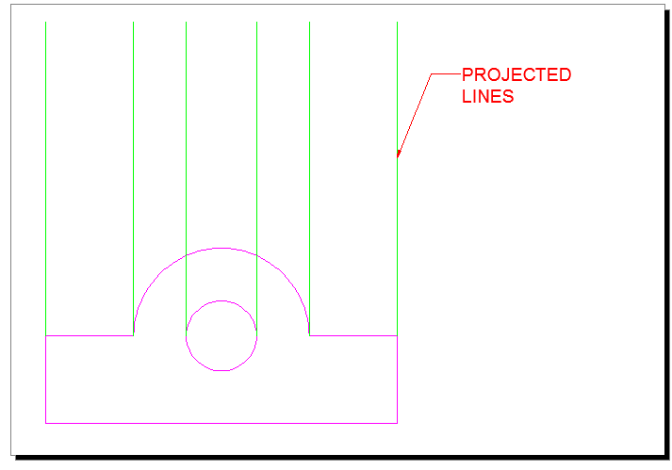

Now that you have the vertical lines, draw the horizontal lines. Make sure you leave enough room to draw the width (via OFFSET) and space between the views.
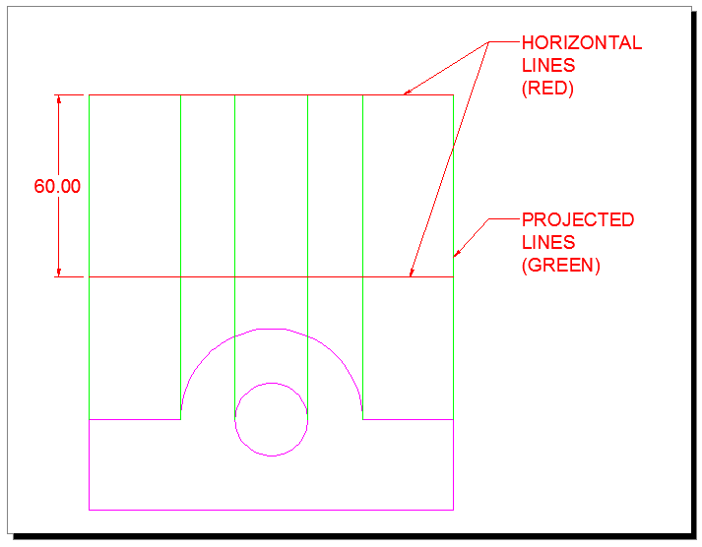
Now you almost have 2 views drawn. Trim the lines so that you are left with just the lines you need.
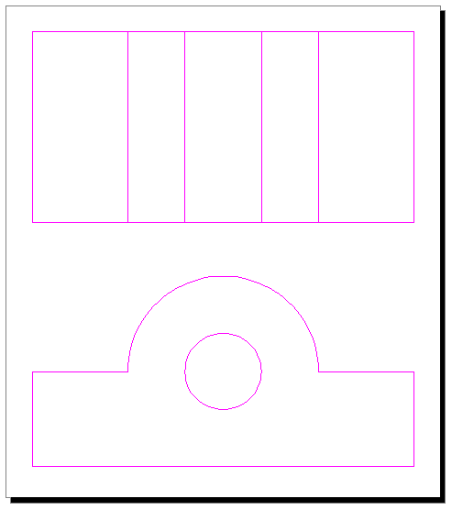
Stop and check to make sure that you didn't forget any lines. It's very easy to miss some.
Now it's time to jump ahead a little and take a side trip. Read Tutorials 4-3 to learn about Linetypes, because you will need them here. After reading the tutorial, return to your drawing and load the Hidden and Center linetypes. These are needed to add more information in your drawing.
If all went well, you should be able to load the linetypes and scale them (LTS with a value of 10 or 12) to fit with your drawing.
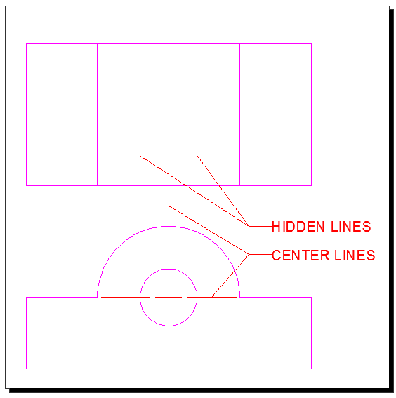
What you see above is the completed Top and Front views. Do you understand why there are "Hidden" lines? They are there to indicate that the hole (circle) is drilled right through the block. Where would the lines be in the hole was only drilled half way through? The center lines are used to show the the hole and the arc have the same center point. These are both common and standard CAD methods and you need to understand them.
One more view to draw. This will be the side/right view. Can you picture it yet?
To get started on the side view, you have to establish where it will be placed in the drawing. In this example and using the 3rd Angle projection, it will be shown to the right of the front view. For exact placement, you need to draw more projection lines.
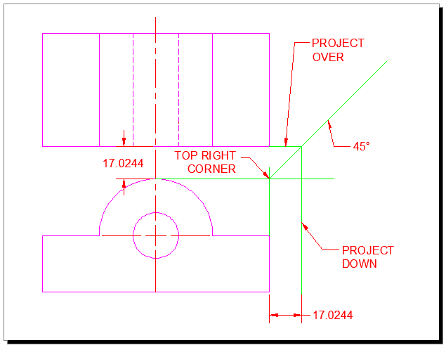
What you see in the image above is that I established the top right corner of my front view by projecting 2 lines. Then I drew a 45 degree line up from the corner.
Now I can start projecting lines from my top view to create the side view. The line that is indicated by the 'Project Down' leader will be the left side of my Right Side View. I would project another from the other side of the top view and that would establish the width of the right side. Also note that by using this technique the top and side views are the same distance from the front view.
From there I just need to project to the right from my front view.
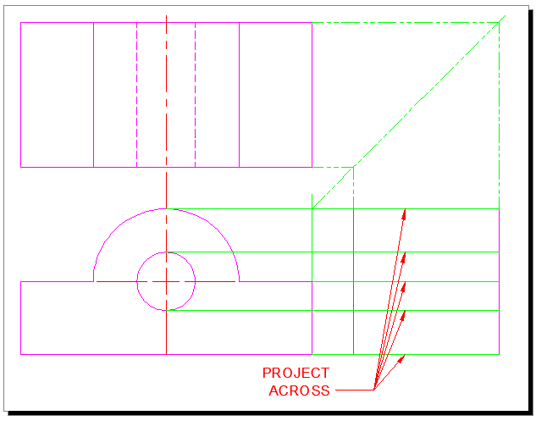
Almost there. Now you just need to trim up some lines and change the linetype for the hidden lines. Final goal is to draw this:
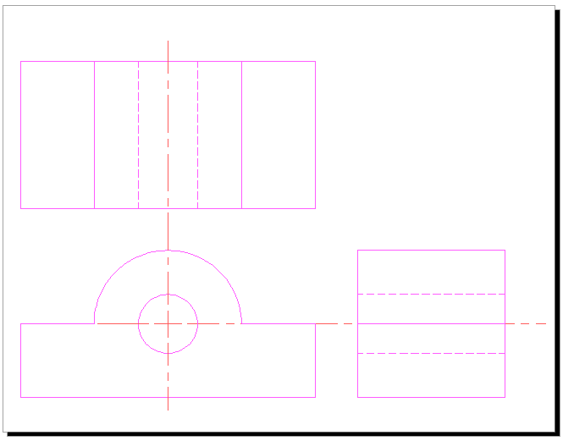
Once you have all of your lines, your center lines and your hidden lines, you are ready to dimension and add any notes that are needed.
Think about what commands you used in this tutorial. You used LINE, CIRCLE, OFFSET & TRIM. You also use Layers and then learned about Linetypes. What this shows is that you don't need to use a lot of commands, but it's your knowledge of how those commands works that makes your reputation as a CAD user.
Extra Practice: Draw the missing Right Side View and the other views (except Isometric) for this drawing.
Extra Practice: Here is a scan from an old (1919) drafting book that I found on Google Books. This image has 4 separate exercise to keep you busy. Draw what you are given, and then draw the missing view.
Extra Practice: Draw the 3 views needed for each of these blocks. Extra 1 - Extra 2
Just one more thing I should mention. This method of drafting can be used in other ways as well.
To the right is a simple piece of duct work drawn in AutoCAD. It's a straight piece that has been cut at an angle so that it can be connected to another piece to form a bend.
Drawing in 3D isn't very hard when you know how. But if I sent this to the manufacturer, he wouldn't really know where to start. So I would have to send him a drawing of the tube rolled out.
This would give him a template to cut the shape and manufacture the part.
Think about what this shape would look like if it was flat. How would you draw it? How would get the curve correct? Do you think that this sounds like a job for Orthographic Projection?
Yes it does.
The drawing below shows how this could be drawn to show all aspects of this part. I have the diameter of the pipe and the length to the top and the length to the bottom. Since I have the diameter, I also have the circumference. The circumference tells me the length of material that will be needed to make the piece.
The part is drawn in Magenta, and the projection lines are in Blue. What I needed to do was use the DIVIDE command to divide both the circle and the line that represents the circumference. Then it was a matter of projecting down and to the right from the circle, and up from the circumference line. This gave me a grid to use for the SPLINE to create the curve. The Auxiliary view was drawn with a few projection lines and an ELLIPSE.
Try this if you like and follow the command line for the commands you don't know. This might be tough, but take your time.
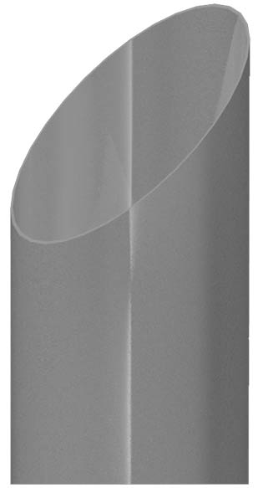

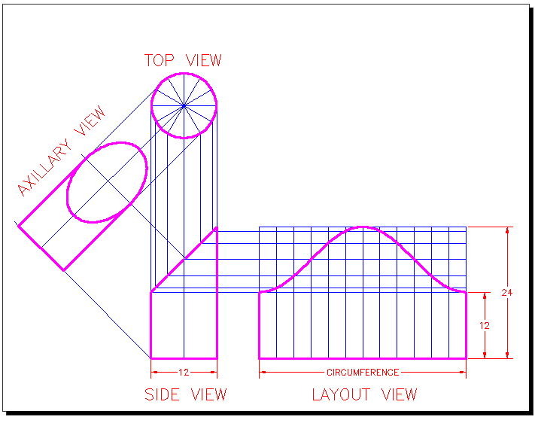

LESSON 1-13:SECTION VIEWS

Topics covered in this Lesson:

Section View Drawing Techniques

Putting your skills to use with Section Views.
In drafting there are a lot times where you want to give a lot of information, but not all of the views are helping to get your message across. Sometimes you just need to slice the object(s) down the middle and show what the guts look like. Using this method, you get a cross section of the part, or a "Section View".
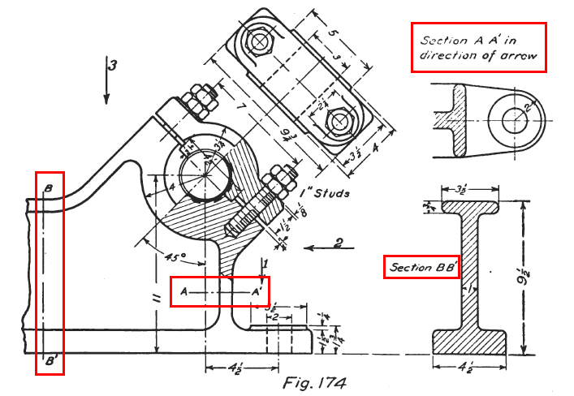

Take a look at the drawing above. You'll see a complex assembly drawing and two different section views. On the far left, you see the line that indicates where Section B-B is. On the right side, you see the section view. Does it make sense to you? What you are seeing is the cross section view of the metal beam part of the of the bracket. It's shown so that you can see what size the area is without having to look at the entire side view of the assembly. Section views are used for clarity.
Look for the indicators for Section A-A. Then look at the top right view. You'll see that the beam part is shown as well as the hole that is drilled through it.
Section views are used in Mechanical and Architechural drafting. Anytime you need to show some detail that isn't readily seen from an exterior view, "cut it up" and draw it.

Required knowledge before beginning
If you haven't already read through Tutorial 1-12 (Orthographic Projection), you should to get familiar with some of the concepts for this tutorial.
You should also jump ahead and read Tutorial 2-5 as it deals with Hatching, which is needed for Section views.

Looking at Section Views
If you understand Orthographic Projection and Hatching (you read the other two tutorials, right?) then you should be able to handle section views easily. Have a look at the image below and see if it all makes sense.
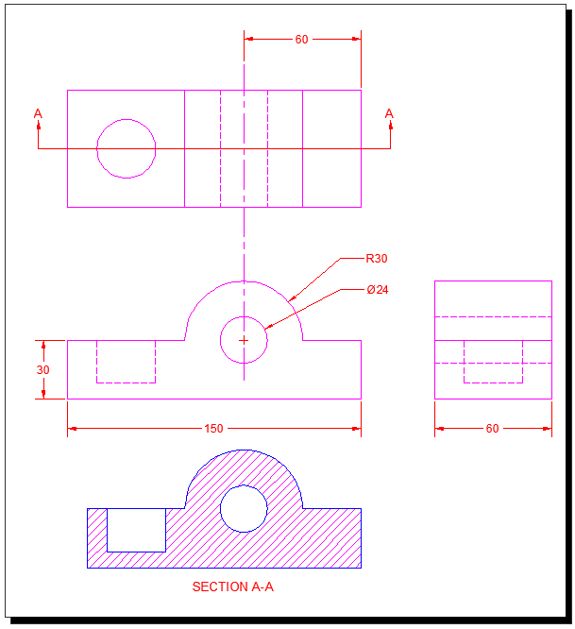

What you see is a very simple block with a hole drilled. This shows that the section view and the front view are almost the same. In fact, I just copied the Front view down to begin the section view. I changed some linetypes and then hatched it.
If you have more than one part in your view, you will need to make sure that it stands out. Here I have the same part as above, but with another piece placed inside it.
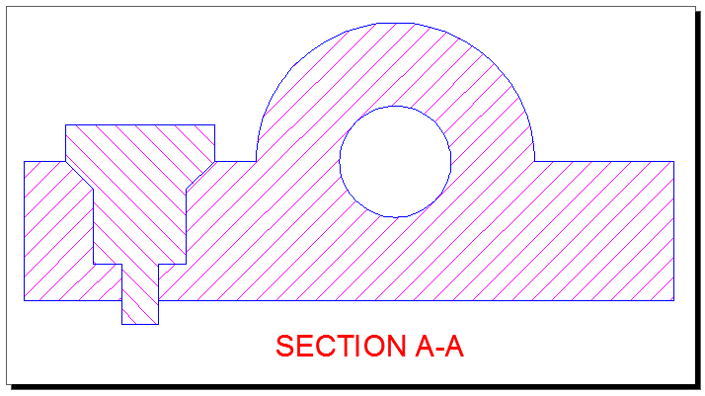

Here's an example of how a section view can be used in Architechural drafting. By using standard hatch patterns, someone else can look at the drawing and see that this shows a concrete foundation with earth on one side.
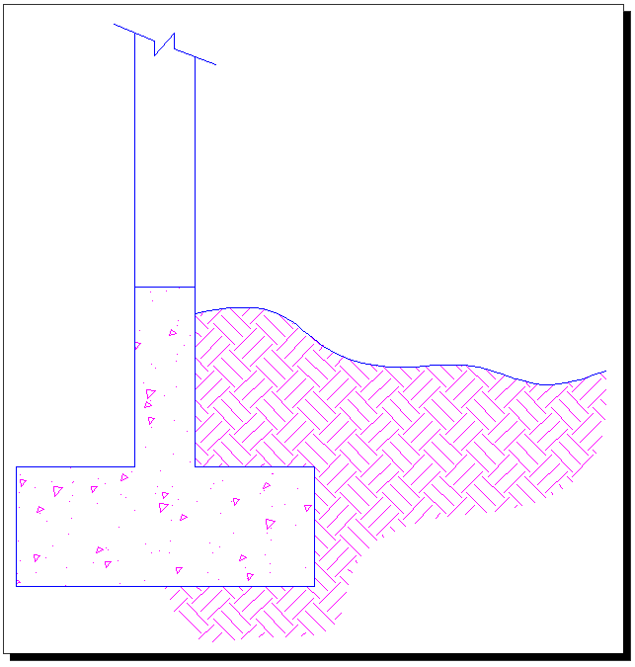

I think by now you're getting the idea of how section views and hatching help to tell the story of what you are drawing.

Drawing Section views in AutoCAD
For this exercise, we'll start with a simple drawing. Begin by drawing the part below, and as you're drawing, think about what the section view will look like. You do not need to draw the Isometric view, it is just for reference.
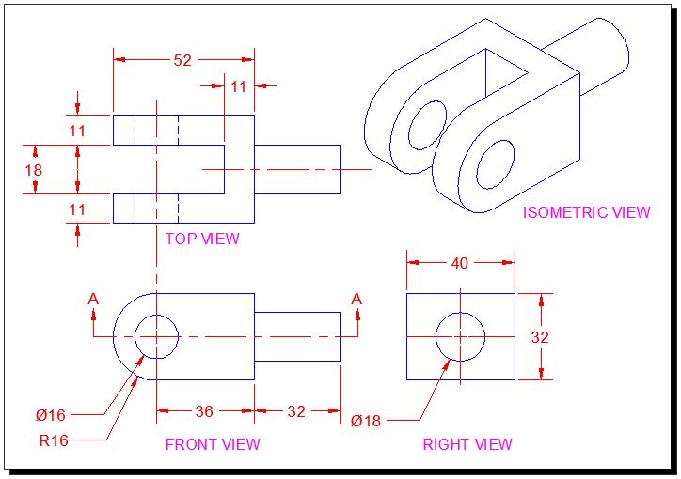

To draw the "Cutting Plane" that marks the section, draw a line and then use the leader command to make the arrows. Add text for the "A"s. Ok - what is your section view going to look like?
The Cutting Plane points up from the front view, It doesn't mean that it's pointing at the top view, but in this case it works. Also note the the Cutting Plane is in the middle. So if you chose the Top View, you're correct.
Copy the Top View. Straight up will work fine. You can keep the dimensions. It's a good idea to make sure that it is directly above the other view in case you have to stretch part of it. Then you can do both views at once.
What lines need to be changed? Do you still need hidden lines?
This is what your Section view should look like before hatching:
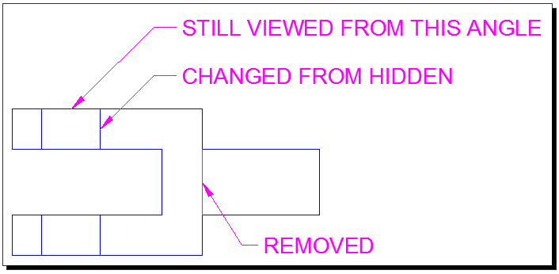

Is it still making sense? You needed to trim the line where the shaft on the right joins the part, because in the section view, this is solid. You needed to change the lines for the two holes from hidden to solid because they are not hidden any more. You should now be ready to add a Hatch patten to the view.
The Hatch command might be a little different depending upon the version that you are using. This example shows AutoCAD 2012.
Start the Hatch command and pick in the spots shown below. You want all three areas picked at the same time so that the hatch creates one object instead of three. This is needed so that you can edit the hatch and all the areas will look the same.

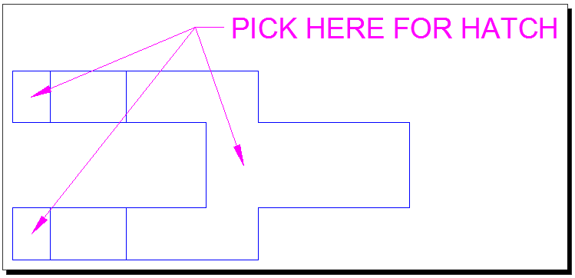

The areas picked will fill up with the last used hatch pattern and settings that were used. That's fine, we'll edit them now.
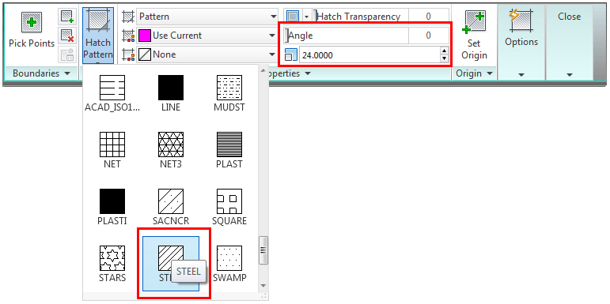
This is a big toobar / ribbon for this command. There are really only three items you need to be aware of to make it work:
- Pattern: The pattern should indicate what material is used in the area that is hatched.
- Angle: Most of the time this will be 0 degrees, but sometimes you want to change it.
- Scale: This is the one that gets changed a lot. If your hatch pattern 'looks solid' - then you usually have to increase the scale because the lines are too close together. If the hatch pattern 'looks empty' - then you might have to scale it down because the lines are too far apart. The scale will vary depending upon what size your drawing is.
If everything went well, the Section view you have should look like this:
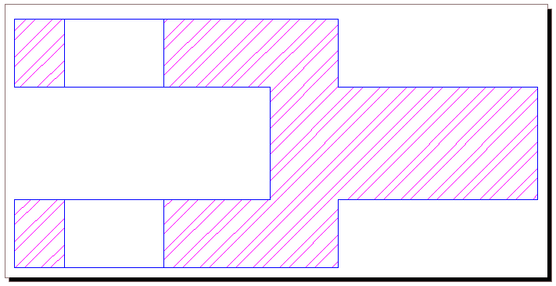
It's up to you if you want to put your hatch on a separate layer. It can help a lot as you get into more complex drawings. As you learn about printing through Layout Tabs, think about how having your Hatch can be useful on it's own layer - and maybe more than one layer.

Other uses for Section Views
Here is a section view that is used to show a break in a solid bar and a pipe. This is a common way of showing long pipes that don't fit in your drawing, just add a break, but dimention the full length.
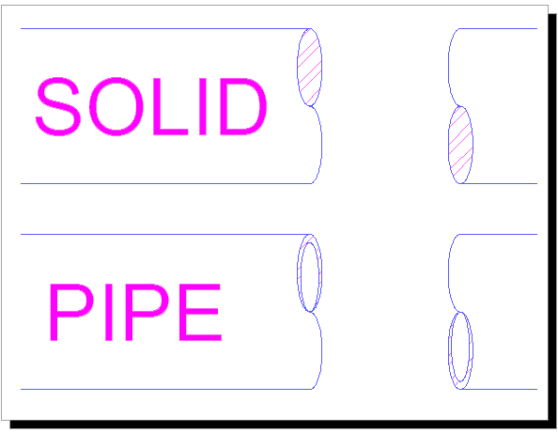

Here's an exercise for you: reproduce the image of a foundation below:

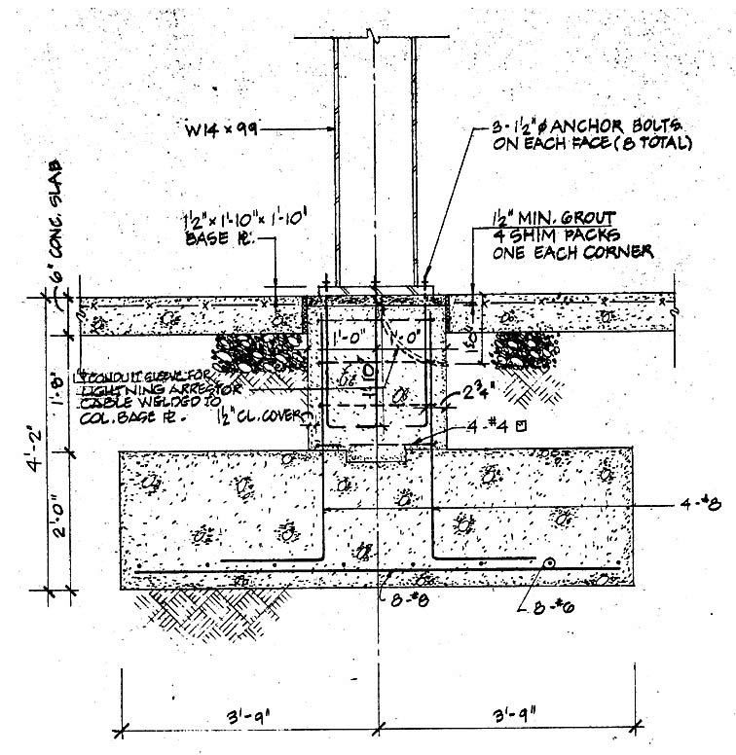

More exercises from Textbook of Machine Drawing. Draw these parts out in Orthographic View and then draw the Section view.

Conclusion
Section views are not usually very difficult to draw, because you should have a lot of the information first. You will draw your sections last and try to base them off of existing drawings first.
If you have the opportunity, look at drawing sets and see where they are used. If you are drawing something try out a section view, it's good practice for Hatching and also for developing your "CAD" eye.

